Water Benefits Calculator for Ethiopia – Version 2:

Technical Guidance Document

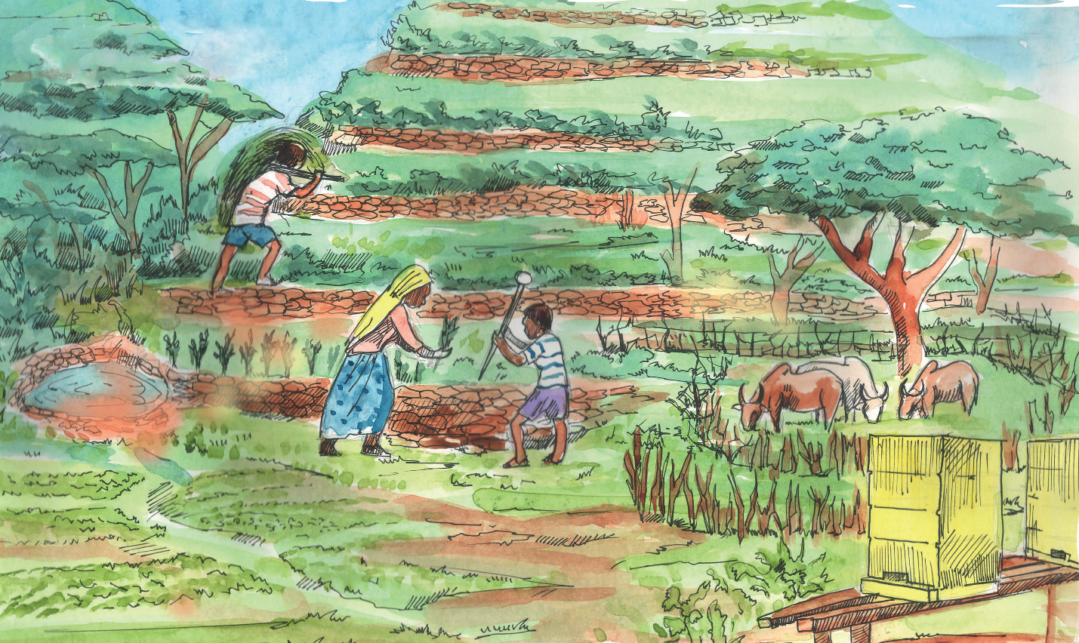

Prepared for Catholic Relief Services

**Drafted September 2020**

****

Contents

[1 Purpose of the WBC tool 1](#_Toc51947718)

[2 WBC Framework 1](#_Toc51947719)

[3 Hydrological Simulation Program 3](#_Toc51947720)

[4 Key Methods and Assumptions 4](#_Toc51947721)

[5 Land Cover Types 5](#_Toc51947722)

[6 Model Inputs and Parameters 12](#_Toc51947723)

[7 Guidance for Installing & Using the WBC 17](#_Toc51947724)

[8 References 28](#_Toc51947725)

[Appendix A: Water Benefits Calculator Glossary 29](#_Toc51947726)

[Appendix B: Weather Time Series Disaggregation Factors 34](#_Toc51947727)

[Appendix C: Model Parameter Input Values 36](#_Toc51947728)

# Purpose of the WBC tool

The Water Benefits Calculator (WBC) for Ethiopia (Version 2 and higher) is a desktop-based tool developed by Catholic Relief Services with funding support from the United States Agency for International Development (USAID). The WBC for Ethiopia was originally developed as a spreadsheet-based tool (Version 1) for three demonstration farms (located within or near Obi, Ziway Dugda, and Awale) prior to being adapted to the current, standalone desktop version.

The WBC can be used to compute water infiltration and runoff and sediment washoff for Ethiopian hillsides and agricultural plots and to compare the relative benefits of implementing one or more management interventions on a hillside/plot relative to a pre-management reference condition or other management scenarios. Specific management scenarios (i.e., involving interventions or alternative cropping) can be configured via the use of transects that represent the different crop and landscape configurations and patterns for a field area of interest. The evolution of agricultural activities, including crop planting, growth, and harvest, are represented in the WBC based on the estimated impact of those activities on key hydrologic processes (e.g., water storage in canopy cover). Results reported by the tool include seasonal and annual runoff, evapotranspiration, recharge, and sediment washoff rate at the hillside and plot scales.

The current version of the WBC (Version 2) will eventually be enhanced to incorporate a cost-benefit module (Version 3), which will allow users to compare relative costs and water quantity/quality benefits across various plot management scenarios. Version 4 of the tool will involve calibration of the hydrologic and sediment washoff practices (as represented in Versions 2 and 3) to data collected from literature sources and the field for Ethiopian agricultural areas where CRS has existing relationships.

# WBC Framework

The WBC tool framework is based on configuration of a **plot** area and an associated set of child **transects** that represent the unique combination of topographic features, land cover, and management interventions for a typical Ethiopian private land area located along a hillslope. A transect defines the representation of topographic features and land use / land cover along the upslope-to-downslope length of the plot (field area) of interest. Within each transect, spatial patterns in land use are segmented as “cells.” Each transect requires specification of appropriate land use segments (i.e., cells), fixed cell width (i.e., the lateral spacing), and the cell length (i.e., the vertical spacing) for each land use segment. Within a transect, the cell length can be varied to configure the vertical spacing of the topographic features. In order to facilitate configuration of spatial patterns, the WBC graphical user interface (GUI) provides a palette of the land cover types that can be added to the transect via basic ‘point-and-click’ action. All transects created within a plot must be specified at the same total length as the prescribed slope length for the plot. A sufficient number of transects must be configured so that the “transect-set” can be reproduced/extrapolated along the cross-slope (lateral) dimension of the plot.

Each WBC **plot** (field area) is contained within (or a child of) a “hillside” area that is created by a user. Each hillside belongs to a particular *project*, which is the highest point of the WBC hierarchy. The relationships between projects, hillsides, plots, scenarios, transects, and cells are illustrated in Figure 1 and can be summarized as follows:

* **Projects**: A user may create one or more projects within the WBC interface. A project is assumed to represent a general area of interest for evaluating interventions, and it can be represented by a single point location specified on a map or via latitude/longitude coordinates. This location is used by the WBC to determine appropriate meteorological data and soil texture to support the modeling of plots.
* **Hillsides**: Each WBC project may contain one or more *hillsides*, which represent geographical area(s) with consistent soil and weather characteristics. A hillside does not have to have a steep slope or grade.
* **Plots**: Each hillside may contain one or more *plots*, with each plot representing a small parcel of land to be specifically analyzed within the WBC. A plot with typically have a surface area of 0.25 to 5 hectares, with a maximum slope length of approximately 400 meters.
* **Scenarios**: One or more scenario(s) may be created within an individual plot. An individual scenario is intended to represent a specific management scenario across one or more transects.
  + **Transects**: Each transect has a fixed width (e.g., 20 meters) and is comprised of multiple *cells* of varying lengths, which collectively represent the full slope length specified for the parent plot.
  + **Cells**: Each cell represents a specific land cover condition along the slope represented by the transect. The WBC simulates the movement of water and sediment washoff from upslope to downslope, and therefore each cell imports water/sediment from the ‘upslope’ cell and exports water/sediment to the next cell downslope.

As depicted in Figure 1, the quantity and size of plots, scenarios, and transects are flexible and can be specified by the user to best match field conditions for each hillside area.

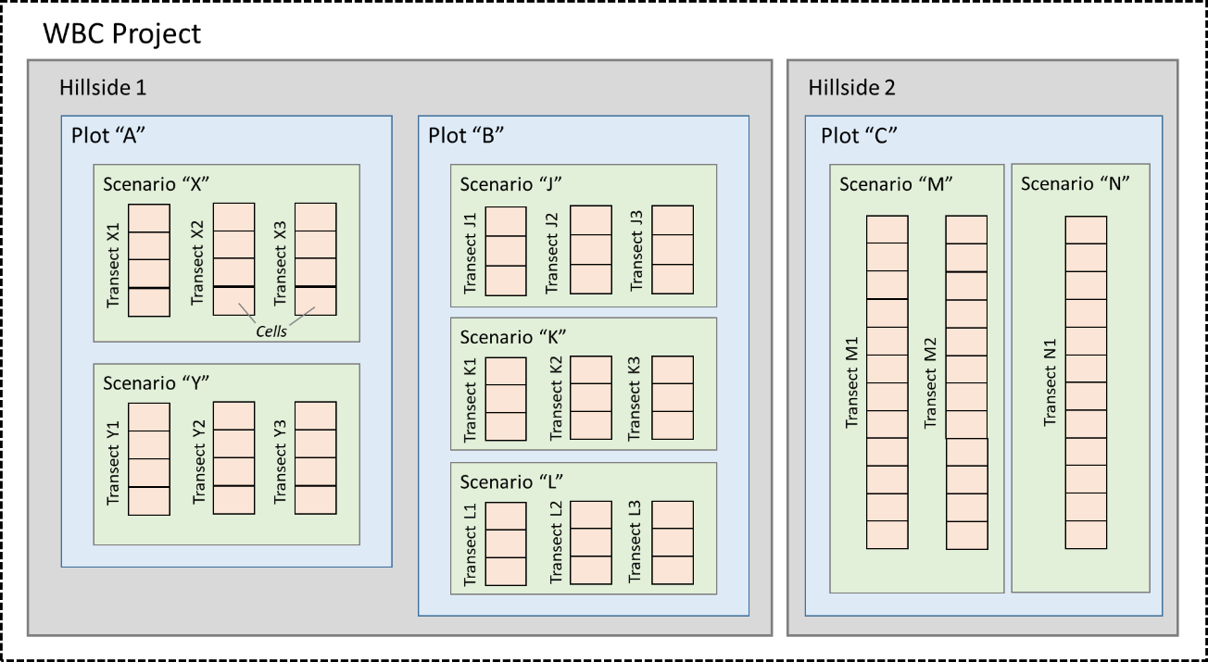

**Figure 1. WBC Entity Hierarchy (project, hillside, plot, scenario, and cells)**

**Appendix A** provides a complete glossary for terms associated with the WBC framework and various aspects of its application to Ethiopian agricultural lands.

# Hydrological Simulation Program

The *Hydrologic Simulation Program - FORTRAN* (HSPF) model is a U.S. EPA program for simulation of watershed hydrology and water quality. HSPF was been used in watershed modeling practice since the 1970s, and there have been hundreds of applications of HSPF all over the world. The HSPF model uses information such as the time history of rainfall and potential evapotranspiration; land surface characteristics such as land-use patterns; and land management practices to simulate the hydrologic and water quality processes that occur in a watershed drainage area. The result of this simulation is a time history (daily, monthly, and annual) of the quantity and quality of simulated runoff from the pervious and impervious land surfaces represented in the model.

The HSPF model consists of a set of modules arranged in a hierarchical structure that support the continuous simulation of a comprehensive range of hydrologic and water-quality processes. A more detailed description of process representation in HSPF is provided in Bicknell et al. (2005). The “PERLND” (pervious land) module of HSPF simulates the water quantity and quality processes that occur on pervious land areas. The PERLND module is implemented in the WBC tool for hydrology and sediment erosion/washoff (nutrients and pesticides are not included in current versions). The WBC implementation of the PERLND module tracks at an hourly timestep storage of water in various above-surface and subsurface compartments or zones (e.g., canopy and unsaturated soil zones) and the movement of water along three flow output paths: overland flow, interflow, and groundwater flow. A total of six (6) storage zones are used to represent the short- and long-term retention of water in the drainage area, with the total water storage quantities and retention timescales dependent on the parameterization of processes that occur on the land surface and in the soil horizons. A schematic of the hydrologic processes represented in HSPF is shown in Figure 2.

The WBC tool currently generates *uncalibrated* model simulations of hydrology and sediment loss from Ethiopian hillslope plot (field) areas. Results from the current tool are well suited for evaluating relative changes between alternative management conditions, and therefore the relative benefits of various management approaches; however, the absolute values should be considered somewhat uncertain and used with caution until the WBC has been calibrated (Version 4, to be released in spring 2021).

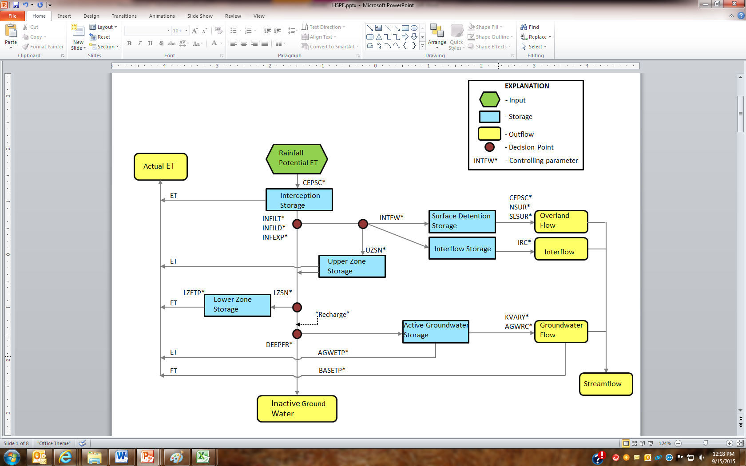

**Figure 2. Hydrologic cycle as modeled in HSPF**

# Key Methods and Assumptions

Key methods and assumptions employed in the WBC are summarized below:

* A daily precipitation time series is required as input, and this series is disaggregated to hourly values by the WBC. The hourly distribution is assumed to follow a SCS type II distribution with peak rainfall occurring at midday.
* A daily potential evapotranspiration (PET) time series is also required as input, and the daily series is disaggregated to hourly values by the WBC. The hourly distribution is assumed to follow a normal distribution centered on midday. Latitude of the weather station and Julian day are used to calculate the average daylight hours per day, which is in turn used to define the duration of the non-zero PET period within each day. The average daylight hours per day for each month for various locations across the globe is available from <http://www.climatemps.com/>.
* Water is assumed to only flow downslope/downstream in the WBC. Therefore, no interaction is assumed between transects (i.e., “cross slope,” along the lateral dimension of the farm). In addition, the WBC currently assumes that no water or sediment are entering the plot from areas located upslope of the plot.
* Within each transect, water and sediment fluxes from an upstream cell are linked, as appropriate, to the downstream or receiving cell. The following assumptions apply for upstream to downstream cell linkage:
  + Surface runoff and interflow from an upstream cell are routed to the receiving cell. The receiving cell, in addition to generating surface runoff from rainfall within its own domain, receives upstream surface runoff as an external input. Similarly, interflow from upstream enters the upper soil zone of the receiving cell.
  + Water entering the lower soil zone and the resulting groundwater (GW) flows are tracked by individual cells (i.e., there is no linkage of GW flows to other receiving cells). The groundwater flow output reported for the simulated farm or field area reflects the sum of the GW flows generated from each cell.
* Planting pits, trenches, level bunds, and level Fanya Juus, which are generally referred to as “infiltration features” below, are simulated based on the following methods and assumptions:
  + Inflows to the infiltration pits/ditches include: 1) direct rainfall to the feature itself, and 2) surface runoff and interflow entering the feature from the upstream cell.
  + Overflow occurs when the actual water storage volume in a pit/ditch exceeds the total capture capacity of that pit/ditch.
  + The volume of water infiltrating into the soil from a pit or ditch is routed to the lower soil zone of the (downstream) receiving cell.
  + All sediment routed to an infiltration pit/ditch via surface runoff from the adjacent upstream cell (if any) will be assumed to deposit in that pit/ditch. As a result, the pit/ditch will gradually fill in with sediment over time, and the total available water capacity of the pit/ditch will decrease. The rate of in-filling for each pit/ditch feature included in the simulation will be reported in the “Results Dashboard” in a future WBC release (Version 3).
* The WBC implicitly represents the planting, growth, and harvest cycles for various crop / land cover types through the scaling of key model parameters influencing hydrology and sediment washoff. Further discussion is provided in the “Model Inputs and Parameters” section.
* The WBC, as currently designed, does not support the evaluation of significant gully areas that may occur between laterally adjacent plots.
* Deep groundwater losses (inactive groundwater in Figure 2), which represent groundwater lost from the basin due to deep percolation (e.g., to a subsurface aquifer), are assumed to be zero.

# Land Cover Types

This section provides a description of the various types of land cover (LC) types currently represented in the CRS WBC tool. Note that any of the LC types discussed below can be assigned to a given cell represented within a user-specified WBC transect. The icons used in the WBC for each land cover type are depicted in each sub-section, in addition to a photograph or illustration of the land cover.

## Hillslope (“Bare Soil” and “Ground Cover”)

Hillslope, which is referred to as “Ground Cover” in the WBC interface, represents the open space, devoid of overstory vegetation, that may occur on managed or unmanaged public lands located upslope of an actively farmed plot area, or, potentially, with a private plot area. Hillslope may contain herbaceous understory vegetation that provides various levels of ground cover (GC). The land cover options provided in the WBC include “Bare soil” to represent bare soil conditions (i.e., no herbaceous ground cover) and other (partially vegetated) hillslope types, with herbaceous cover increasing in increments of 25%, to represent various levels of percent ground cover:

* Ground Cover (0-25%) – low vegetated condition
* Ground Cover (25-50%) – low to moderately vegetated
* Ground Cover (50-75%) – moderate to highly vegetated
* Ground Cover (75-100%) – highly vegetated

In Figure 3, an area enclosure is used to improve land with degraded vegetation and/or soil through natural regeneration to increase ground cover by excluding grazing livestock. Hillslope areas are assumed to follow the general slope characteristic of the “parent” plot area.

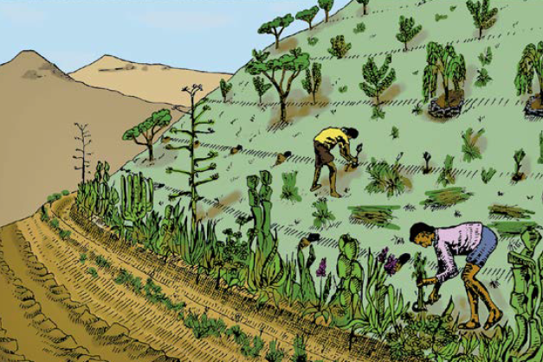

|  |  |
| --- | --- |
| **Icon** | **Land Cover Type** |
| C:\Data\Repositories\CRSWBC_desktop\Imgs\SegTypes\BareSoil_tile.png | Bare soil  *(unvegetated hillslope)* |
|  | Ground Cover (X-Y%)  *(vegetated hillslope)* |

**Figure A. Illustration of Ethiopian hillslope areas (left) and land cover icons used in the WBC (right)**

## Maize/Sorghum, Small Grain, and Chat

These land cover categories refer to various Ethopian crop types planted on a hillslope without terracing. Crop types are grouped into the following 3 options: maize or sorghum; chat (or khat); or small grains such as wheat, teff, or barley (Figure 4).

### 

|  |  |
| --- | --- |
| **Icon** | **Land Cover Type** |
| **C:\Data\Repositories\CRSWBC_desktop\Imgs\SegTypes\HS_Maize_tile.png** | Maize/Sorghum |
| **C:\Data\Repositories\CRSWBC_desktop\Imgs\SegTypes\HS_Grain_tile.png** | Small Grain |
| **C:\Data\Repositories\CRSWBC_desktop\Imgs\SegTypes\HS_Chat_tile.png** | Chat / Khat |

**Figure 4. Ethiopian crop categories (clockwise from upper left: maize, teff, wheat, sorghum) (left) and land cover icons used in the WBC (far right)** *[photos reproduced from the U.S. Department of Agriculture]*

## Bench Terrace + Maize/Sorghum, Small Grain, or Chat

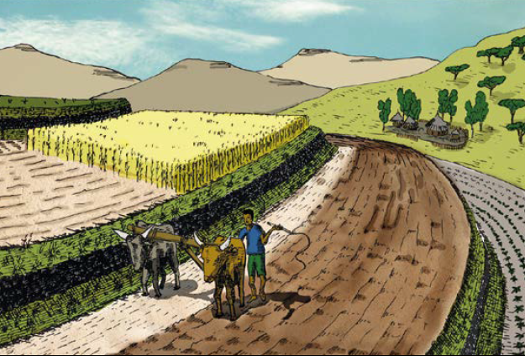A bench terrace is a conservation structure where a slope is converted into a series of steps, with a horizontal cultivated area on the step and steep risers between two steps (Figure 5). Relative to the previous land cover options, the bench terrace option has the same 3 crop type groups, but a much shallower slope.

|  |  |
| --- | --- |
| **Icon** | **Land Cover Type** |
| **C:\Data\Repositories\CRSWBC_desktop\Imgs\SegTypes\BT_Maize_Sorghum_tile.png** | Bench + Maize/Sorghum |
| **C:\Data\Repositories\CRSWBC_desktop\Imgs\SegTypes\BT_Grain_tile.png** | Bench + Small Grain |
| **C:\Data\Repositories\CRSWBC_desktop\Imgs\SegTypes\BT_Chat_tile.png** | Bench + Chat / Khat |

**Figure 5. Illustration of bench terrace configuration on an Ethiopian plot area (left) and land cover icons used in the WBC (right)**

## Tree Planting (young or mature)

Tree planting for conservation is an activity to improve the vegetative ground cover, thereby reducing runoff and soil erosion and producing wood (Figure 6). Tree planting by itself is a soil and water conservation measure because the tree roots stabilise the soil and the tree protects the ground from the impact of raindrops. Two options are available based on the relative maturity of the tree canopy. Generally, the “young” option will be appropriate for trees that have been planted less than 5 years prior.

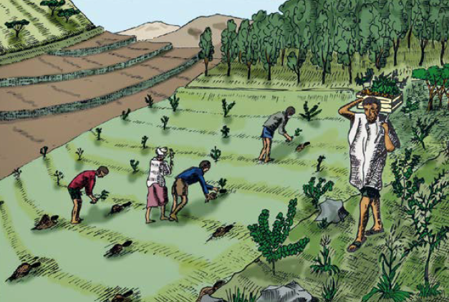

|  |  |
| --- | --- |
| **Icon** | **Land Cover Type** |
| **C:\Data\Repositories\CRSWBC_desktop\Imgs\SegTypes\TreePlanting_Young_tile.png** | Trees (young) |
| **C:\Data\Repositories\CRSWBC_desktop\Imgs\SegTypes\TreePlanting_Mature_tile.png** | Trees (mature) |

**Figure 6. Illustration of tree planting on an Ethiopian plot area (left) and land cover icons used in the WBC (right)**

## Terrace + Tree Planting (young or mature)

A hillside terrace is a structure along the contour, where a strip of land is levelled for tree planting (Figure 7). Hillside terraces are up to 1 m wide and constructed at about 2–5 m vertical intervals. Hillside terraces are only applied if there is a strong reason to justify their construction.

|  |  |
| --- | --- |
| **Icon** | **Land Cover Type** |
| **C:\Data\Repositories\CRSWBC_desktop\Imgs\SegTypes\HS_Tree_Young_tile.png** | Terrace + young trees |
| **C:\Data\Repositories\CRSWBC_desktop\Imgs\SegTypes\HS_Tree_Mature_tile.png** | Terrace + mature trees |

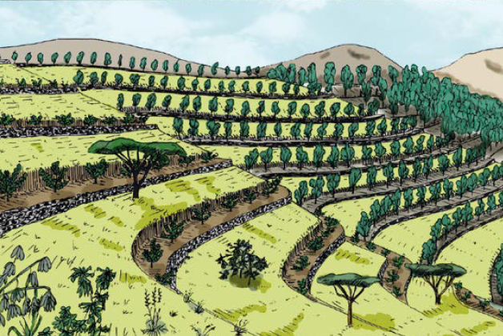

**Figure 7. Illustration of trees planted along terraces on an Ethiopian plot (left) and land cover icons used in the WBC (right)**

## Microbasin (young or mature)

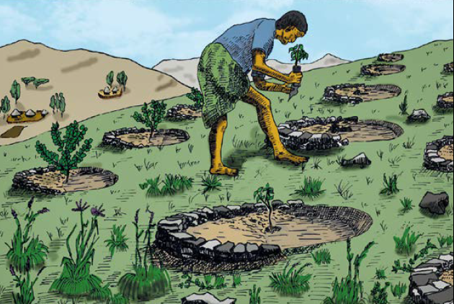A microbasin is a small structure with the shape of a half or a full circle, excavated to obtain a small basin for planting a tree (Figure 8). Microbasins vary in size according to their designation to conserve water; they are small in moist agroecological zones and large in dry ones. Generally, the “young” option will be appropriate for microbasins that have had trees planted less than 5 years prior.

|  |  |
| --- | --- |
| **Icon** | **Land Cover Type** |
| **C:\Data\Repositories\CRSWBC_desktop\Imgs\SegTypes\MicroBasin_Young_tile.png** | Microbasin (young) |
| **C:\Data\Repositories\CRSWBC_desktop\Imgs\SegTypes\MicroBasin_Mature_tile.png** | Microbasin (mature) |

**Figure 8. Illustration of microbasins (left) and land cover icons used in the WBC (right)**

## Grass Strip (or Live Barrier)

A grass strip is a ribbon-like band of grass laid out on cultivated land along the contour. Usually, grass strips are about 1 m wide and spaced at 1 m vertical intervals. They are mainly used to replace physical structures on soil with good infiltration (sandy, silty) on gentle slopes.

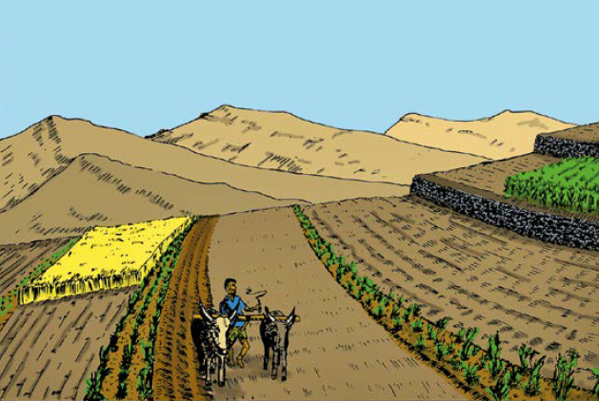

|  |  |
| --- | --- |
| **Icon** | **Land Cover Type** |
| **C:\Data\Repositories\CRSWBC_desktop\Imgs\SegTypes\GrassStrip_tile.png** | Grass Strip |

**Figure 9. Illustration of grass strips (left) and land cover icons used in the WBC (right)**

## Planting Pit (trench)

A pit (or trench) is a short ditch dug along the contour (i.e. across the slope) to trap runoff water in dry and moist areas. The trees will be planted in a planting pit in the center of the trench. Trenches are particularly useful to help rehabilitate degraded lands.

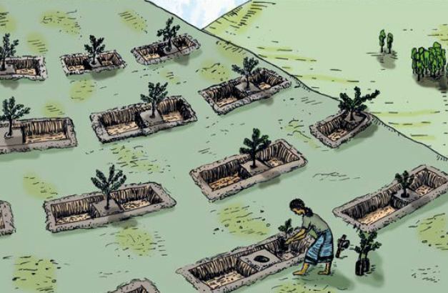

|  |  |
| --- | --- |
| **Icon** | **Land Cover Type** |
| **C:\Data\Repositories\CRSWBC_desktop\Imgs\SegTypes\PlantingPit_tile.png** | Planting Pit |

**Figure 10. Illustration of planting pit (left) and land cover icons used in the WBC (right)**

## Fanya Juu

A level Fanya Juu is an embankment along the contour, made of soil and/or stones, with a basin at its lower side. The Fanya Juu reduces or stops the velocity of overland flow and consequently soil erosion. By contrast with the Level Bund, the soil in a Fanya Juu is moved upslope for construction. The water retention basin is thus at the lower side of the wall. Tied ridges about every 10 metres are also used to prevent runoff from flowing sideways.

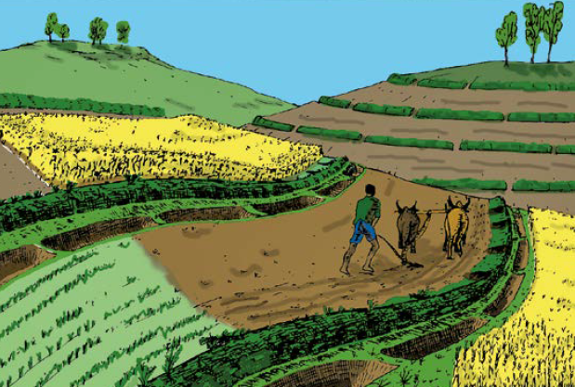

|  |  |
| --- | --- |
| **Icon** | **Land Cover Type** |
| **C:\Data\Repositories\CRSWBC_desktop\Imgs\SegTypes\LevelFanyaJuu_tile.png** | Level Fanya Juu |

**Figure 11. Illustration of Fanya Juu (left) and land cover icons used in the WBC (right)**

## Level Bund (rock, soil, or vegetative)

A level bund is an embankment along the contour, made of soil and/or stones, with a basin at its upper side. The bund reduces or stops the velocity of overland flow and consequently soil erosion. A vegetative bund has crops or other vegetation planted on the bund.

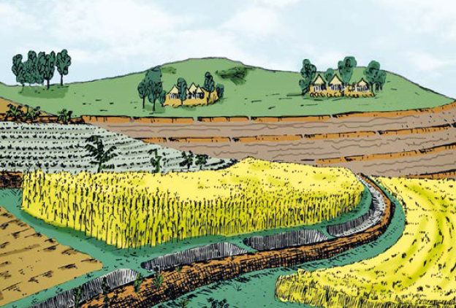

|  |  |
| --- | --- |
| **Icon** | **Land Cover Type** |
| **C:\Data\Repositories\CRSWBC_desktop\Imgs\SegTypes\BundRocks_tile.png** | Bund (rock) |
| **C:\Data\Repositories\CRSWBC_desktop\Imgs\SegTypes\BundGrass_tile.png** | Bund (grass) |

**Figure 12. Illustration of Level Bund (left) and land cover icons used in the WBC (right)**

# Model Inputs and Parameters

Inputs to the WBC include daily time series for key meterological variables, distribution factors to disaggregate daily meterological inputs to hourly values, and a suite of model input parameters that affect calculations of hydrologic and sediment erosion/washoff processes. These inputs are described in the following sub-sections.

## Meteorological Time Series

The WBC requires input of daily time series for precipitation (mm day-1) and potential evapotranspiration (PET, mm day-1) for one or more calendar years. The HSPF-based WBC model simulation requires hourly inputs for both precipitation and PET, and so disaggregation factors are used to generate hourly values from the daily total values. For precipitation, a triangular distribution centered on noon of each day is employed (i.e., the maximum precipitation rate occurs at noon). The peak and slope of the triangular distribution depends on the magnitude of the daily precipitation. The disaggregation of daily PET is also center on noon of each day, and the distribution depends on the month of year, in order to capture changes in ET due to the number of daylight hours. Month-to-month changes in PET for Ethiopia are minimal due to the proximity of the country to the Equator. **Appendix B** provides tables detailing the disaggregation factors used for both precipitation and PET.

The current WBC Version 2 database contains precipitation time series for four weather station locations for the January 1, 2000 through December 31, 2007 period (Table 1). Although data were provided for additional stations, only the four selected locations were determined to have sufficient temporal coverage and completeness of daily observations. External data or estimates were not available for daily PET, so it was necessary to apply an empirical method to estimate PET based on available air temperature data for the stations listed in Table 1. WDMUtil, a utility program that is commonly used to support HSPF modeling, was used to apply the Hamon method (1963) based on daily minimum/maximum air temperature to generate a daily PET series for two locations with sufficient air temperature data: Dire Dawa and Ziway Dugda. For simplicity, the PET time series for Arsi Negele and Meki stations were assigned the PET series developed for Dire Dawa.

**Table 1. Meteorological Station Locations and Data Sources**

| **Station Location** | **Coordinates (latitude, longitude)** | **Time Period** | **PET Assignment** |
| --- | --- | --- | --- |
| Arsi Negele | (7.35212, 38.65779) | 2000-2007 | Dire Dawa |
| Dire Dawa | (9.9667, 42.5333) | 2000-2007 | Dire Dawa |
| Meki | (8.151, 38.817) | 2000-2007 | Dire Dawa |
| Ziway Dugda | (7.9333, 38.700) | 2000-2007 | Ziway Dugda |

The current set of weather stations and datasets provide coverage for a relatively small portion of central Ethiopia. Therefore, additional work will be conducted to incorporate additional weather stations/locations, with the objective of having coverage sufficient to represent any agricultural area within Ethiopia that might be evaluated using the WBC.

## Model Parameters

The current version of the WBC includes a total of 32 model parameters that are used to initialize water storages and drive hydrologic and sediment processes during the model simulation. Each of these parameters is specified for each of the land cover types described in Section 5, with the values configured to reflect important differences between the various types in the hydrologic or sediment washoff behavior. For example, for a given soil type, a vegetated hillslope (ground cover) cell is parameterized to capture more water in canopy storage and infilitrate water at higher rates than a “bare soil” cell.

Base values are specified for all parameters in the WBC database. In some cases, the parameter values are modified just prior to (or during) the WBC simulation to capture important changes in plot conditions that are specified by the user or calculated throughout the run. Scale factors are applied to a subset of parameters during initialization of a simulation to represent the soil texture conditions for the hillside/plot and the residue conditions within the plot area. During the simulation, additional scale factors are applied on a monthly basis to represent Ethiopian crop cycles (i.e., the timing of planting, plant growth, and harvesting) and the effects of these cycles on evapotranspiration, canopy storage, infiltration, and other hydrologic and sediment processes.

Version 4 of the WBC will incorporate updates to the various parameters based on *calibration* of the model to relevant data collected from field studies and existing literature sources. Model calibration is described in USEPA guidance (1994) as the “process of adjusting model parameters within physically defensible ranges until the resulting predictions give the best possible fit to the observed data.” The following sections provide brief discussion of specific calibration considerations for a subset of the input parameters.

**Appendix C** provides a complete list of current model base input parameter values and scale factors by specific parameter and land cover type (Tables C-1 through C-5). The standard user mode within the WBC interface does not provide any access to view or edit the model parameters or scale factors that have been defined in the WBC and its database. However, the ability to view and modify parameters will be a feature of the advanced (or “superuser”) mode, which will be incorporated into Version 3 of the tool.

#### Hydrology Process & Initial Condition Parameters

The WBC requires the specification of 16 parameters that effect the hydrologic behavior of a particular land cover type and an additional 6 parameters that specify initial water storage in specific hydrologic compartments (Table 2). Several of the hydrologic parameters (e.g., INFEXP, INFILD) are assigned generally accepted/recommended values across all land cover types, and these parameters are typically not modified via calibration or based on cell properties (such as vegetative cover). Based on work conducted to date to configure and apply the WBC for three Ethiopian demonstration farms, the model results are most sensitive to the following hydrologic parameters: INFILT, UZSN, LZSN, LZETP, and CEPSC. These parameters are briefly discussed below. Parameters that are scaled to account for field-specific soil texture or seasonal changes within crop cycles include: INFILT, LZETP, and CEPSC (values provided in Appendix C).

##### Infiltration (INFILT)

The INFILT parameter represents an index to the mean soil infiltration rate. Although it is correlated to soil infiltration capacity, maximum infiltration rate, or permeability rate, it is typically much lower than those values (USEPA 2000). In addition to the use of INFILT for the majority of land cover options available in the WBC, the WBC also links selection of soil texture to an INFILT value for infiltration-based conservation practices (ditch/pit, Fanya Juu, level bund). To support calibration of the WBC, field measurements of infiltration rates may be done using single or double ring infiltrometer method.

##### Soil Zone Storage (UZSN and LZSN)

These parameters represent the nominal upper zone soil (UZS) and lower zone soil (LZS) moisture storages. Similar to the INFILT parameter, these parameters are not directly translated from field-based observations even though UZSN and LZSN might theoretically be linked to real-world measurements of soil characteristics (porosity, depth to a limiting layer) to compute a soil storage capacity. LZSN (lower zone storage) is often initially estimated based on both regional soil characteristics and annual precipitation patterns. UZSN (upper zone storage) is related to topography, land surface characteristics, and agricultural practices. The HSPF technical guidance document for hydrology gives suggestions for parameterizing UZSN and LZSN (USEPA 2000). Field observations that could support calibration of the WBC for these parameters include land surface characterization (vegetation, residue, tillage, roughness, etc.), opportunity for depression storage, or potentially digging test pits for recording characteristics of the soil profile.

##### Evapotranspiration (LZETP and PET)

Actual evapotranspiration (AET) simulated by HSPF is influenced by a number of factors, including the UZSN and LZSN values (described above), the CEPSC value (described below), the index to lower zone evapotranspiration (LZETP), and the potential evapotranspiration (PET) input time series. Based on our experience, the LZETP parameter and PET time series are key inputs to evaluate and adjust during the calibration to establish the distribution of annual precipitation into either water routed through the landscape (as surface, interflow, or groundwater outflow) or AET. Field measurements of AET require long-term monitoring stations and complex equipment, and therefore collecting data will likely not be feasible for the initial WBC calibration effort. Instead, research will be conducted to identify Ethiopian evapotranspiration estimates on a regional or national scale. Special emphasis might be given to studies that report annual evapotranspiration versus precipitation and any that report differences in evapotranspiration as a function of land cover characteristics.

##### Vegetative Interception & Cover (CEPSC and COVER)

The vegetation interception of precipitation (CEPSC) and the fraction of the land surface shielded from rainfall (COVER) influence both the hydrology and sediment calibration and are typically correlated for a given land cover input. (Note that COVER is a sediment process parameter, but it is discussed here for convenience.) For example, a densely vegetated hillslope will have relatively high values of both CEPSC and COVER, while a bare soil will have the lowest values. These values often change throughout the year as a function of crop or natural vegetation growth cycles. Estimates of vegetative cover or crop residue cover can be completed in the field using quadrats or transects, or potentially remote sensing methods to help inform the WBC calibration. Note that the WBC accounts for the effects of crop growth cycles on these and other input parameters, and the time-variable nature of these parameters will be factored into the calibration effort.

**Table 2. Hydrologic Process Parameters**

| **Type** | **Name** | **Definition** | **Units** |
| --- | --- | --- | --- |
| Process (interception) | CEPSC | Interception storage capacity | mm |
| Process (surface) | LSUR | Length of the assumed overland flow plane | m |
| Process (surface) | SLSUR | Slope of the assumed overland flow plane | m m-1 |
| Process (surface) | NSUR | Manning's n for the assumed overland flow plane | --- |
| Process (infiltration) | INFILT | Index to the infiltration capacity of the soil | mm hr-1 |
| Process (infiltration) | INFEXP | Exponent in the infiltration equation | --- |
| Process (infiltration) | INFILD | Ratio between the max and mean infiltration capacities over the PLS | --- |
| Process (USZ) | UZSN | Upper zone nominal storage | mm |
| Process (interflow) | INTFW | Interflow inflow parameter | --- |
| Process (interflow) | IRC | Interflow recession parameter; under zero inflow, this is the ratio of interflow outflow rate for the current day relative to the prior day’s rate | --- |
| Process (LSZ) | LZSN | Lower zone nominal storage | mm |
| Process (LSZ) | LZETP | Lower zone evapotranspiration (ET) parameter; an index to the density of deep-rooted vegetation | --- |
| Process (GW) | KVARY | Parameter which affects the behavior of groundwater recession flow, enabling it to be non-exponential in its decay with time | mm-1 |
| Process (GW) | AGWRC | Basic groundwater recession rate if KVARY is zero and there is no inflow to groundwater (rate of current day’s flow to prior day’s flow) | --- |
| Process (GW) | BASETP | Fraction of remaining potential E-T which can be satisfied from baseflow if enough is available | --- |
| Process (GW) | DEEPFR | Fraction of groundwater inflow which will enter deep (inactive) groundwater and, thus, be lost from the system | --- |
| Initial Condition | AGWS | Active groundwater storage | mm |
| Initial Condition | CEPS | Interception storage | mm |
| Initial Condition | IFWS | Interflow storage | mm |
| Initial Condition | LZS | Lower zone storage | mm |
| Initial Condition | SURS | Surface (overland flow) storage | mm |
| Initial Condition | UZS | Upper zone storage | mm |

#### Sediment Process Parameters

The remaining 10 input parameters included in the WBC influence the simulation of soil accumulation, erosion/washoff, and transport from the land surface (Table 3). These parameters are included in equations that are based on the quantity of surface runoff simulated by the hydrology component of the WBC. Similar to hydrology, several of the sediment process parameters (e.g., AFFIX, JRER, JSER, JGER) are assigned fixed values that are common across all land uses and will likely not be modified through the model calibration process. Parameters that are scaled to account for field-specific soil texture, seasonal changes within crop cycles, or residue management include: COVER, KRER, and KSER (values provided in Appendix C).

Key parameters that are influenced by land cover and other factors and therefore will be addressed through calibration include KRER and KSER. These sediment parameters represent the coefficients in the soil detachment and soil washoff equations, respectively. KRER is correlated to the Universal Soil Loss Equation (USLE) K factor and may be initially estimated from any Ethiopia resources that can be gathered regarding USLE K factors. The KSER parameter is complex, representing the impacts of soil surface conditions, sediment particle size, slope, and overland flow length. Calibration is the recommended approach for evaluating and establishing this parameter (USEPA 2006). Like the AET estimates, field measurements of soil erosion (sediment yields) typically require long-term monitoring stations and equipment deployments that are beyond the scope of the initial WBC calibration effort. Shorter-term, plot-scale estimates of soil erosion to support WBC calibration could be conducted for individual storm events or simulated rainfall events, but these too may be logistically challenging. The most practical field observations that could be made to support WBC calibration include estimates of conservation practice sediment infilling rates including characteristics of the contributing drainage area (size, land cover, etc.). We also recommend researching Ethiopia monitoring or modeling based studies that report soil erosion rates (e.g., Haregeweyn et al. 2015).

**Table 3. Sediment Process Parameters**

| **Type** | **Name** | **Definition** | **Units** |
| --- | --- | --- | --- |
| Sediment | SMPF | Supporting management practice factor | --- |
| Sediment | AFFIX | Parameter to affix detached sediment to soil matrix (i.e., fraction of detached storage affixed per day) | day-1 |
| Sediment | COVER | Fraction of land surface that is shielded from rainfall erosion | --- |
| Sediment | KRER | Detachment coefficient, dependent on soil properties (sheet & rill) | --- |
| Sediment | JRER | Detachment exponent, dependent on soil properties (sheet & rill) | --- |
| Sediment | KSER | Coefficient for transport of detached sediment (sheet & rill) | --- |
| Sediment | JSER | Exponent for transport of detached sediment (sheet & rill) | --- |
| Sediment | KGER | Coefficient for scour of matrix soil | --- |
| Sediment | JGER | Exponent for scour of matrix soil | --- |
| Sediment | DETS | Initial detached sediment storage | kg ha-1 |

# Guidance for Installing & Using the WBC

The following sections provide descriptions of the various WBC features and complete instructions on how to interact with the WBC, including installing the software; creating projects; configuring hillsides, plots, scenarios, transects and land cover cells; setting up and executing simulations; and evaluating model results.

## WBC Overview & Specifications

The WBC is a desktop-based tool that requires installation on a personal computer (PC) running the Windows 10 (or newer) operating system. The WBC is a 64-bit software program based on the Microsoft .NET Framework and developed in the Visual Basic (VB.NET) language. The software relies on the open-source DotSpatial .NET library for mapping capabilities and the ProEssential.NET (version 7) library for charting. The WBC is supported by a SQLite relational database that resides locally on a user’s computer. All information added to the tool by a user is stored in this local database. Version 2 of the tool does not support transfer (export/import) of WBC project information from the database from one user to a different user’s database; however, this capability may be incorporated into a future version.

The following are required and recommended specifications for personal computers on which the WBC will be installed and used:

* Operating System: Windows 10 (64-bit version required)
* Central Processing Unit (CPU): clock speed of 2.0 GHz or higher recommended
* Memory (RAM): 4 GB minimum required for core WBC installation; 8 GB minimum required for loading and viewing imagery files within the program.
* Hard Disk storage: 0.25 GB minimum required for core WBC installation; 10 GB minimum required for core program plus all imagery and raster files.
* Supporting software: Microsoft Excel (2010 or newer) recommended for reviewing spreadsheet files exported from the WBC “Results Dashboard”.

## WBC Software Installation

The core WBC software can be installed by placing the “WBC\_Ethiopia.msi” installation file and the “WBC\_Ethiopia” subfolder in a common folder location. Double-clicking the MSI file will initiate the installation process on Windows 10. The software will be installed into the computer’s “*C:\Program Files\WBC\_Ethiopia*” folder, and the application name in Windows will be “Water Benefits Calculator.” The core installation provides all of the necessary components to create, modify, and run WBC simulations; however it does not include supporting imagery and soil raster datasets for the mapping tool. The imagery and raster data files are excluded from the main installation due their size (multiple gigabytes per file). Separate installation files are not available for the imagery/raster files at this time, and so it is necessary to manually incorporate any desired files into the WBC installation folders. All images and rasters datasets have three separate files with \*.tif, \*.mwi, and \*.mhi extensions. Available, processed files include coarse-resolution, country-level imagery (“Ethiopia\_imagery.tif”), soil texture (“soil\_texture.tif”), and medium-resolution imagery for nine Woredas: Arsi Negele, Babile, Deder, Dire Dawa, Heben Arsi, Melka Belo, Midega Tola, Shalla, and Ziway Dugda. The files associated with these datasets must be placed in the “*C:\Program Files\WBC\_Ethiopia\data\Spatial\Imagery*” folder so that they can be recognized by the WBC mapping utility.

Several enhancements will be made to the WBC software by LimnoTech between fall 2020 and summer 2021. Updates, including for Version 3 and Version 4, will be provided as either a full installation (as described above) or as “patches” to be applied to an existing installation. Patches will be provided in separate installation (\*.msi) files that, when run against an existing installation, will selectively update some components of the software, such as the main executable file and the SQLite database.

## WBC User Interface

Following installation, the WBC can be opened using a desktop or Windows menu shortcut or by searching the computer for “Water Benefits Calculator.” Once the WBC has loaded, the “Home” page will be shown by default, and the navigation menu on the left side of the interface will display the following main headings (Figure 13):

* Home
* User Guidance
* WBC Projects
* WBC Simulations
* Results Dashboard

The “Home” page provides an overview description of the tool and buttons to navigate to the “User Guidance” and “WBC Projects” pages. The “User Guidance” page (Figure 14) provides a glossary that provides definitions for key terms included in the WBC, which is identical to the information provided in Appendix A of this document. A link to the slide-based user guidance document is also provided at the bottom of this page.

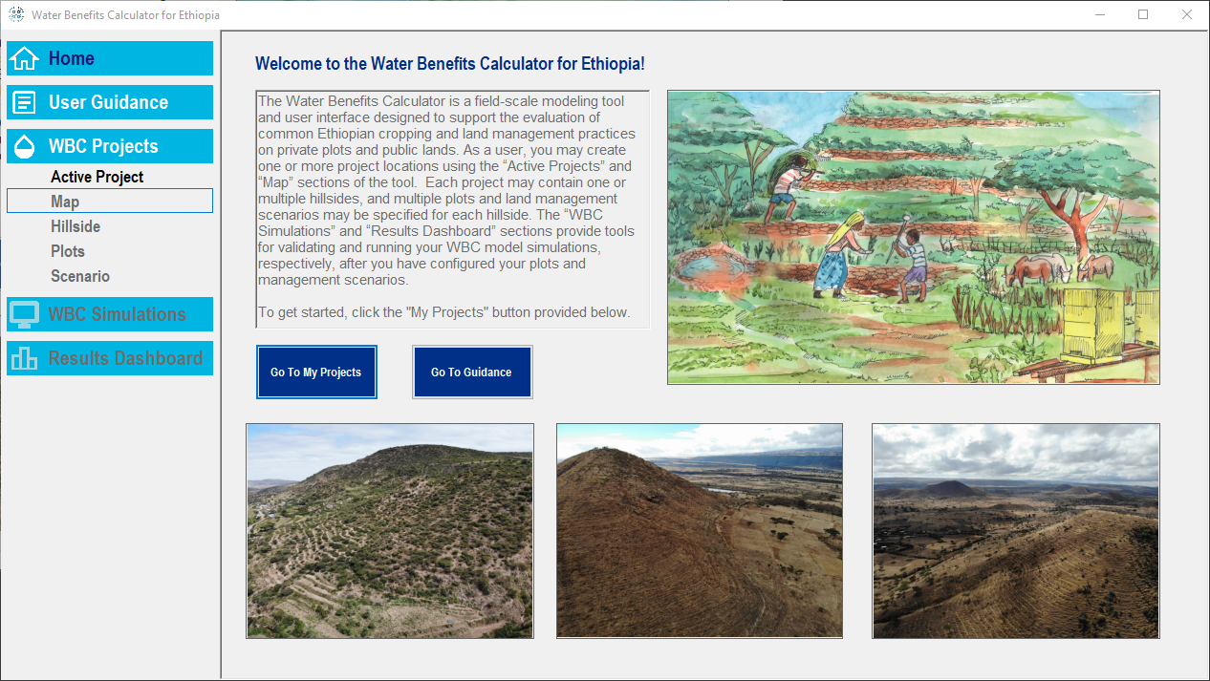

**Figure 13. WBC Graphical User Interface and Home Page**

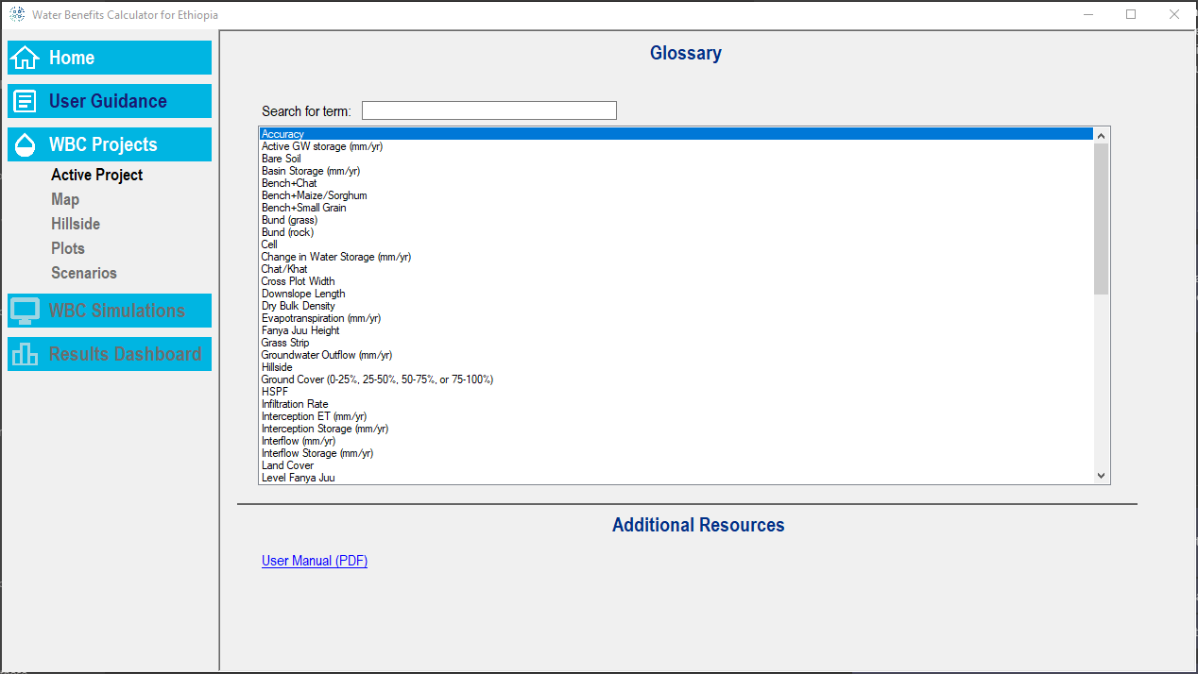

**Figure 14. WBC User Guidance Page**

## Creating & Editing WBC Projects

The “Active Project” page (Figure 15) serves as the entry point into the WBC tool, and it supports creating a new project or selecting an existing project to be modified. In addition to the requirement of specifying a project name, users are encouraged to include brief description of each project.

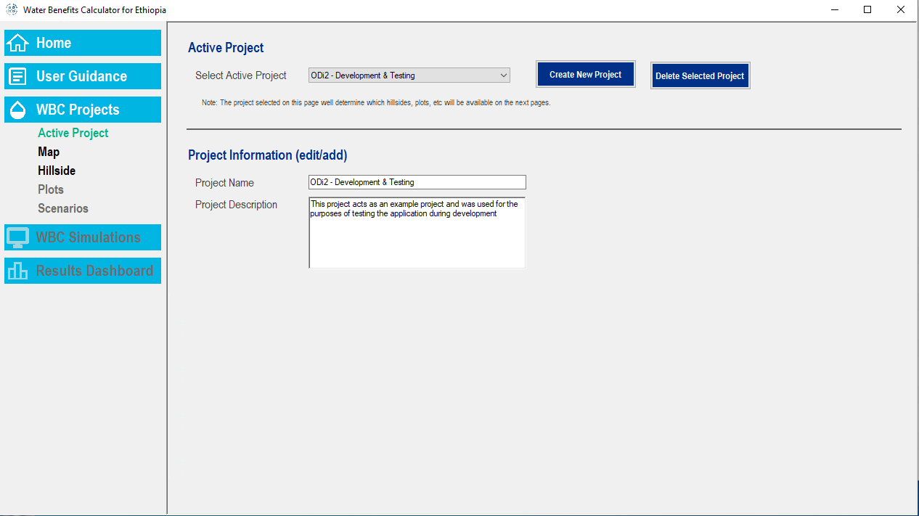

**Figure 15. WBC “Active Project” Page**

Prior to creating or selecting a project, the additional options under the “WBC Projects” main heading will be disabled (greyed out). Selection of a project on the “Active Project” page will enable the “Map” page.

### Defining Project Location via the Mapping Tool

The mapping interface (“Map” page) provides tools for adding spatial reference to your WBC project. The location of your project can be specified in one of the following ways:

1. By clicking on “Place WBC Project Location on Map” button and then clicking a point location on the map, or
2. By entering the latitude and longitude coordinates (in decimal degrees) into the “Latitude” and “Longitude” boxes and then clicking the “Update Project Point” button to add the project location to the map.

Using either approach will add a yellow star to the map corresponding to your project location (Figure 16). At present, only one point location can be specified for each project, and so a project must represent hillsides and plots that are in the same general vicinity. Once your project has been assigned a location, the “Hillside” page will be enabled.

The map interface also provides several layers that you can toggle on/off, including the project layer, weather station locations, polygons representing Ethiopian political boundaries (country, region, zone, and Woreda), polygon layers representing nine different Woredas, and, optionally, imagery and soil texture raster layers.

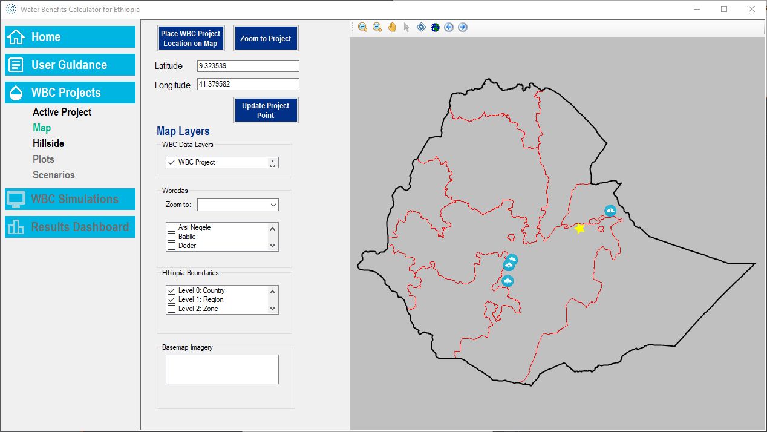

**Figure 16. WBC Mapping Utility (“Map” page) with Example Project Location**

### Configuring Hillsides

The “Hillside” page allows the user to create (or edit) one or more hillsides within each project (Figure 17). A new hillside feature can be created by clicking the “Create New Hillside” button and specifying a name for the hillside. An existing hillside feature can be permanently deleted from the WBC by selecting the feature in the “Select Hillside” box and then clicking the “Delete Selected Hillside” button.

Each hillside feature must be populated with certain required fields (inputs), and there are several optional fields that may be populated as well. Required fields include:

* Soil texture (via menu; e.g., “Sandy Clay”);
* Dry Bulk Density (g/cm3);
* Soil Depth (cm); and
* Precipitation location, with one or more simulation years selected.

Optional fields, which do not factor into the model simulation, include a description of the hillside, infiltration rate (mm/hr), and organic matter content (as a percentage).

The WBC will automatically assign a default weather/precipitation station by selecting the station that is in closest proximity to the project location specified on the “Map” page. If the (optional) “soil\_texture.tif” raster file is included in the WBC folder/file hiearchy (see installation notes above), then the WBC will also assign a default soil texture based on the raster cell associated with the project coordinates. If necessary, the assigned weather station and soil texture class can be manually overriden by the user.

The “Soil Depth” input currently must be specified as a value (e.g., 40 cm), although future versions of the WBC may use a more qualitative approach (e.g., low, medium, or high depth/thickness). The WBC model calculations are very sensitive to this important parameter because soil depth is used to define the maximum storage of the soil upper zone storage (UZS) and lower zone storage (LZS), which in turn influence the rate of water infiltation and runoff. In typical HSPF model calibrations, these parameters are initialized based on regional data (e.g., geologic conditions) and then refined through calibration of the model to (daily or monthly) streamflow data. Although it will not be possible to calibrate the WBC for Ethiopia to daily streamflow data, Version 4 will be calibrated to available hydrologic and sediment data and it is anticipated that more specific guidance on defining soil depth will be provided at that time.

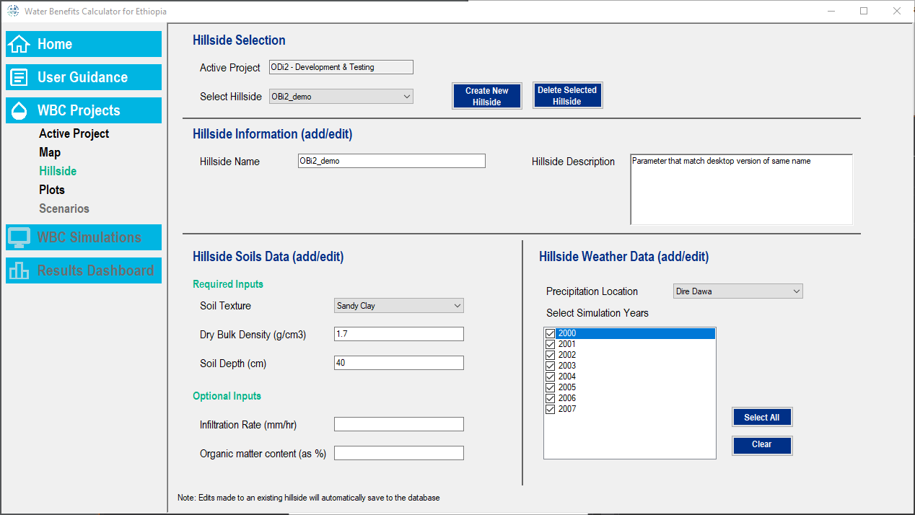

**Figure 17. WBC Hillside Configuration Page**

### Configuring Plots

The “Plots” page allows the user to create (or edit) one or more plots within each hillside feature (Figure 18). A new plot feature can be created by clicking the “Create New Plot” button and specifying a name for the plot. Similar to a hillside, an existing plot can be permanently deleted from the WBC by selecting the feature in the “Select Plot” box and then clicking the “Delete Selected Plot” button.

In addition to the plot name and description, each plot must be populated with certain required fields (inputs), including:

* Slope (as a percentage);
* Cross Plot Width (in meters);
* Downslope Length (in meters); and
* Residue condition.

For plots that will contain one of the four infiltration feature types (i.e., Planting Pit, Fanya Juu, Rock/Soil Level Bund, and Vegetated Level Bund), the initial depth of each type must also be specified (in meters).

Each plot is idealized as a rectangular surface area located within the specified hillside. The “Cross Plot Width” represents the ‘height’ of the plot (from upslope to downslope) and the “Downslope Length” represents the cross-slope (i.e., perpendicular, along a contour) dimension of the plot. The residue iput is intended to capture the general residue management conditions for the plot as “low”, “medium”, or “high.” High residue infers that significant residue is left on the plot area between harvesting of a crop and planting for the next crop cycle, while low residue refers to a minimal cover of the soil between harvesting and planting.

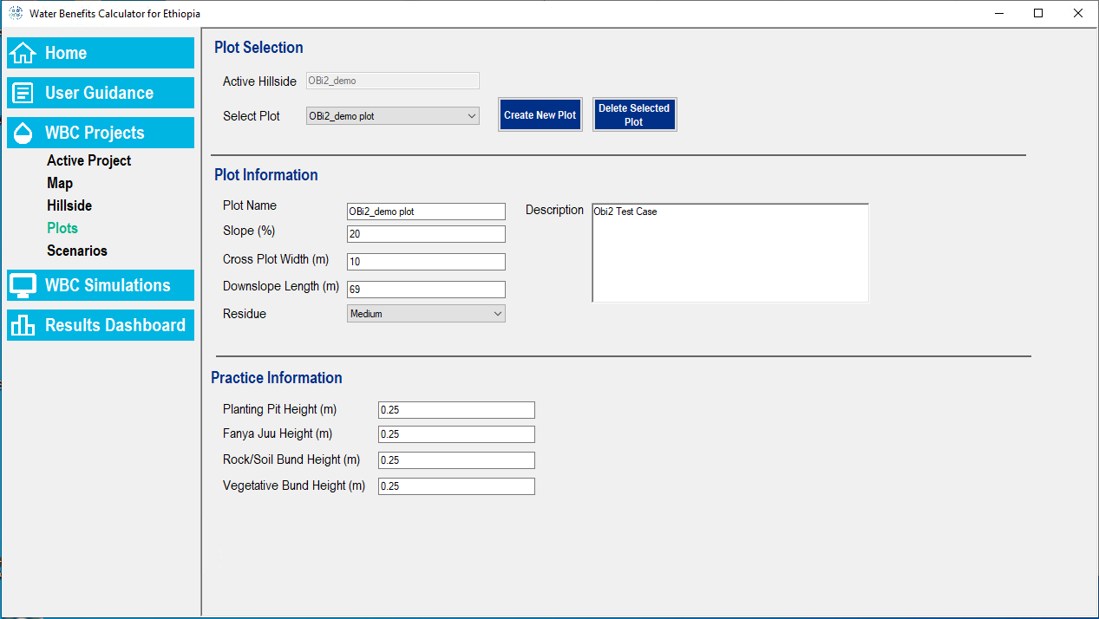

**Figure 18. WBC Plot Configuration Page**

### Configuring Scenarios

The “Scenarios” page allows the user to create (or edit) one or more scenarios within each plot feature (Figure 19). The WBC provides flexibility in the number of scenarios assigned to a specific plot and how those scenarios are configured. A new scenario can be created by clicking the “Create New” button and specifying a name. An existing scenario can be permanently deleted from the WBC by selecting the item in the “Select Plot” box and then clicking the “Delete Selected” button.

Each scenario can contain any number of transects to represent the “parent” plot, and the transects can have a varying number of cells (or segments). Transects are created and deleted via the “Add Transect” and “Delete Transect” buttons. The information required for each transect includes the total width of the transect (see “Width (meters)” input box) and the cell (segment) information, which is displayed in the “Edit Transect Layout” section. Cells can be added to the layout by clicking the “Add Cell” button as many times as needed, clicking a land cover option in the “Land Cover Palette”, and then clicking one or multiple cells to assign the land cover type. Each cell must also have its length specified (in meters). If cells must be deleted from the layout, they must be deleted by clicking the “Remove Cell” link in the “Delete” column, beginning with the most downslope cell in the transect and working upslope.

The transects assigned to a given plot must meet the following criteria:

1. The total length of each transect, defined as the sum of the lengths of all “child” cells, must be equal to the “Downslope Length” specified for the parent plot. Note that a warning message will be displayed in red text below the “Add Transect” button if the transect length does not match the plot downslope length.
2. The sum of the transect widths within a plot/scenario must be equal to or less than the “Cross Plot Width” for the plot. If the cumulative width of the transect is *less than* the cross-plot width, then the WBC will scale (extrapolate) the results for the transects proportionally to represent the entire plot width and area.

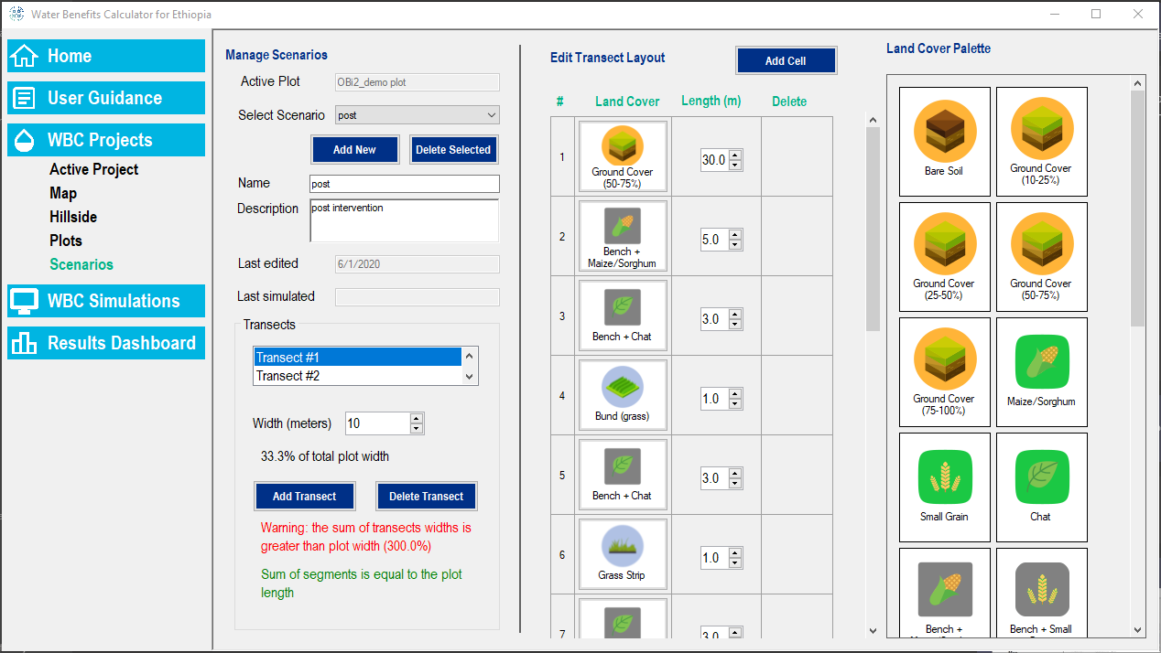

**Figure 19. WBC Scenario Configuration Page**

## Running WBC Simulations

Once the user has configured one or more projects, including the associated hillside(s), plot(s), and scenarios/transects, the “WBC Simulations” page can be used to select and execute simulations for any fully populated scenarios. Available scenarios for the currently selected project will be listed as rectangular objects in the interface, and the user can either manually select the entries or use the “Select All” and “Deselect All” buttons. Once the desired scenarios have been selected, the “Run” button should be clicked to initialize the batch of simulations.

Prior to running a simulation for particular scenario, the WBC will run a series of input validation checks to ensure that the inputs provided for the scenario (including the parent hillside and plot) are consistent with acceptable ranges and data types for each field. If a scenario fails to pass the validation checks, its entry will be given a red background and a report of the validation error(s) will be provided. In this case, the user will need to revisit the inputs for the scenario based on the error messages that were generated.

Scenarios that pass all WBC validation checks and for which the model is completed successfully will be shown with a green background. This indicates that results are now available for the scenario in the WBC database. Once one or more scenarios has been run in a project, the “Results Dashboard” can be used to review and export the results.

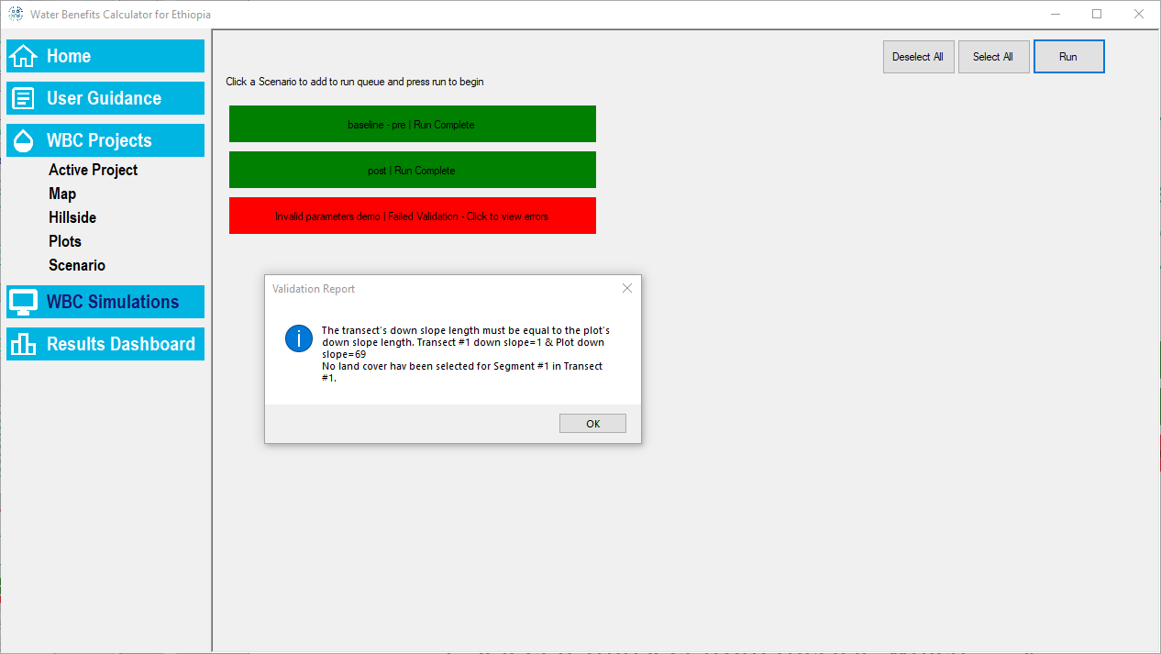

**Figure 20. WBC Simulations Page**

## Evaluating WBC Results (“Results Dashboard”)

The WBC interface includes a *Results Dashboard* to display hydrology and sediment results for the pre- and post-intervention farm configurations. There are three different tabs (subpages) that provide various ways to compare and contrast the results of scenarios generated for the current plot (i.e., as selected on the “Plots” page):

* Scenario Details (Figure 21);
* Compare Scenarios (Figure 22); and
* Raw Results Summary (Figure 23).

The “Scenario Details” tab provides a complete summary of a single selected WBC scenario, including a table of the hydrologic results and the sediment load exported from the plot for the scenario. Key hydrologic pathway results (e.g., runoff, infiltration) are also summarized graphically on a watershed schematic and a pie chart.

The “Compare Scenarios” tab supports the selection of multiple scenarios and up to two output variables to compare for the scenarios (e.g., precipitation, runoff). Updates to selected scenarios and variables will be reflected in the column/bar chart.

Finally, the “Raw Results Summary” page provides a table of the detailed results for each scenario associated with the plot (and for which model results are available). In this view, results can be exported to a Microsoft Excel spreadsheet by selecting a scenario, selecting the desired parameters under the “Set Export Parameters” option, and then clicking the “Export to Excel (xlsx)” button.

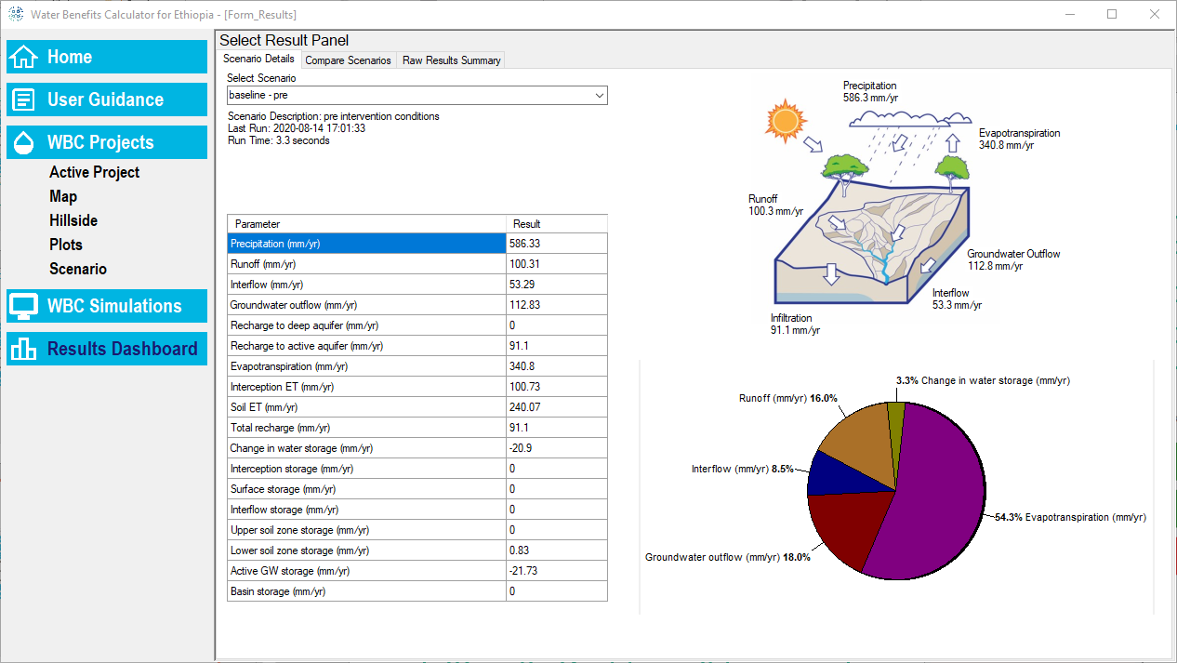

**Figure 21. “Scenarios Detail” Tab in the WBC Results Dashboard**

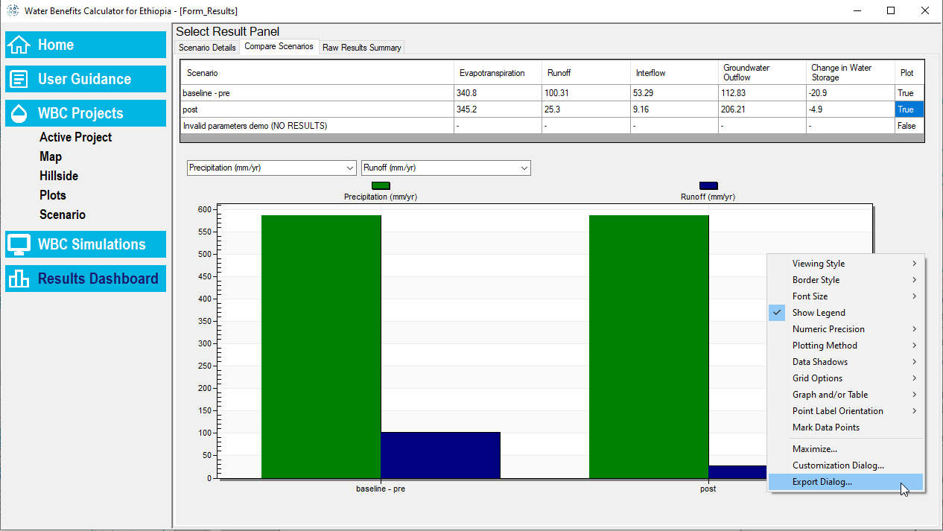

**Figure 22. “Compare Scenarios” Tab in the WBC Results Dashboard**

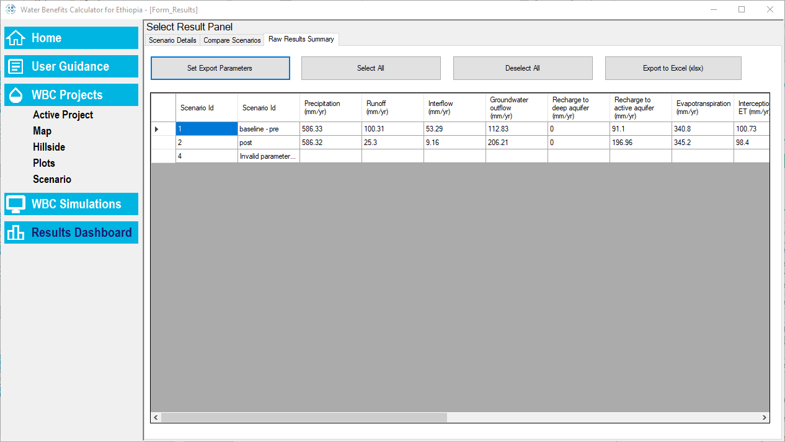

**Figure 23. “Raw Results Summary” Tab in the WBC Results Dashboard**

### Summary of Key Output Variables

The following are definitions for key terms used in the “Results Dashboard” tabs described above:

* *Evapotranspiration:*Quantity of water lost through the combination of evaporation from the soil surface and transpiration through plant respiration. Evaporation + transpiration = evapotranspiration. The WBC breaks down evapotranspiration into *Interception ET (leaves)* and *Soil ET.* “Interception ET” represents the contribution of canopy interception storage to total ET, and “Soil ET”represents ET losses from the soil.
* *Runoff*: Water that immediately runs off the soil surface during a precipitation event and is not used by plants or absorbed into the soil.
* *Interflow:* Water that flows downslope within the upper soil zone (usually the top 10 cm or so).
* *Recharge:* Represents the quantity of water entering the shallow groundwater storage.
* *Groundwater Outflow:* This is water that has percolated into the groundwater storage and then discharged into downstream rivers and springs.
* *Change in water storage:*Represents the overall change across all water storage compartments (i.e., final storages relative to initial storages at the beginning of the simulation or the start of a user-selected reporting period).
* *Water budget check:*It is a diagnostic output and should be reported as zero. It represents the water balance as follows:
  + Precipitation = ET + Runoff + Interflow + Groundwater outflow ± change in storage
* *Sediment Load:* Represents landscape sediment erosion.

Appendix A provides a complete glossary for all key WBC terms, including those summarized above.

# References

Bicknell, B.R., Imhoff, J.C., Kittle, J.L., Jobes, T.H., Donigian, A.S. 2005. Hydrological Simulation Program – FORTRAN. User’s Manual – Version 12.2. Environmental Research Laboratory Office of Research and Development US Environmental Protection Agency, Athens, Georgia 30605. June 2005.

Hamon, W.R., 1963. “Computation of Direct Runoff Amounts From Storm Rainfall.” Int. Assoc. Sci, Hydrol. Pub. 63:52-62.

USEPA. 2000. BASINS Technical Note 6. Estimating Hydrology and Hydraulic Parameters for HSPF

<https://www.epa.gov/sites/production/files/2015-08/documents/2000_08_14_basins_tecnote6.pdf>

USEPA. 1994. Report of the Agency Task Force on Environmental Regulatory Modeling: Guidance, Support Needs, Draft Criteria and Charter. EPA-500-R-94-001. Washington, D.C.

USEPA. 2006. BASINS Technical Note 8. Sediment Parameter and Calibration Guidance for HSPF

<https://www.epa.gov/sites/production/files/2015-08/documents/2006_02_02_basins_tecnote8.pdf>

# Appendix A: Water Benefits Calculator Glossary

**Table A-1. Water Benefits Calculator Glossary**

| **Term** | **Definition** |
| --- | --- |
| Accuracy | Accuracy refers to how close a measurement is to the true or accepted value. |
| Active GW storage (mm/yr) | Difference between final and initial water storage within the active/shallow groundwater (GW) layer in a plot for a given scenario, expressed as an annualized rate of change. The active GW storage will tend to be large relative to other storages (i.e., interception, surface, soil, and interflow). |
| Bare Soil | Land that has no vegetation or NRM intervention. |
| Basin Storage (mm/yr) | Difference between final and initial standing water storage above the soil surface across all infiltration basin features (e.g., pits, Fanya Juu) in a plot for a specific scenario, expressed as an annualized rate of change. |
| Bench+Chat | A bench terrace with chat planted on it. |
| Bench+Maize/Sorghum | A bench terrace with maize/sorghum planted on it. |
| Bench+Small Grain | A bench terrace with small grain, such as teff, planted on it. |
| Bund (grass) | A bund, which is a small mound built along the contour of a hillside, that has grass planted in the mounded soil. |
| Bund (rock) | A bund, which is a small mound built along the contour of a hillside, that has rocks stacked on the mound to stabilize the soil. |
| Cell | A **transect** is comprised of cells. A cell is represented by one type of land cover and is the same width as the **transect** but can have its own length. The cumulative lengths of all cells in a single **transect** must sum to the total length of the **transect**, which is equal to the **downslope length** of the parent plot. |
| Change in Water Storage (mm/yr) | Difference between final and initial total storage of water within a plot for a specific scenario, expressed as an annualized rate of change. This result represents the sum of water storage within the following compartments: canopy interception, upper/lower unsaturated soil layers, and the shallow aquifer layer. |
| Chat/Khat | *Catha edulis* is a flowering plant native to Ethiopia. |
| Cross Plot Width | The horizontal or cross-slope width (perpendicular to the slope of the plot), in meters, of the plot being modeled. |
| Downslope Length | The vertical length (or top to bottom length), in meters, of the plot being modeled. |
| Dry Bulk Density | Also known as Bulk Density, Dry Bulk Density is a measurement of a dry soil’s mass divided by the total volume it occupies. This value can change for different soil types and is dependent on how much the soil has been compacted. |
| Evapotranspiration (mm/yr) | Annual average rate of water exiting a plot across all evapotranspiration (ET) pathways. This value represents the sum of ET from interception, the unsaturated (upper/lower) soil zones, and the upper aquifer layer. |
| Fanya Juu Height | The vertical depth of the level Fanya Juu channel given in meters. |
| Grass Strip | A grass strip is a ribbon-like band of grass laid out on cultivated land along the contour. Usually, grass strips are about 1 m wide and spaced at 1 m vertical intervals. They are mainly used to replace physical structures on soil with good infiltration (sandy, silty) on gentle slopes. |
| Groundwater Outflow (mm/yr) | Annual average rate of water that exits the plot as outflow from the active aquifer layer, for a specific scenario. |
| Hillside | The second level of the WBC, right below project, a hillside is a geographical area with consistent soil and weather characteristics. A hillside does not have to have a steep slope or grade. |
| Ground Cover  (0-25%, 25-50%, 50-75%, or 75-100%) | Represents land cover conditions for a generic hillslope area/cell, with the selected ground cover (in 25% intervals) representing the degree to which vegetation covers the area. |
| HSPF | *Hydrological Simulation Program - FORTRAN* (HSPF) is a comprehensive package for simulation of watershed hydrology and water quality. It is the primary simulation engine the WBC runs on. |
| Infiltration Rate | The infiltration rate is a measure of how fast water enters the soil, typically expressed in millimeters per hour. |
| Interception ET (mm/yr) | Annual average rate of water exiting the plot as evapotranspiration from canopy interception storage (under a specific scenario). |
| Interception Storage (mm/yr) | Difference between final and initial water storage intercepted by vegetation canopy that extends above the ground surface (e.g., crops, trees, etc.), for a plot under a specific scenario (expressed as an annualized rate of change). |
| Interflow (mm/yr) | Annual average rate of water exiting the lower boundary of the plot via interflow, for a plot under a specific scenario. “Interflow” is shallow subsurface flow through the unsaturated soil zone, which differentiates it from groundwater outflow. |
| Interflow Storage (mm/yr) | Difference between final and initial water storage in the interflow compartment for a plot under a specific scenario, expressed as an annualized rate of change. Like surface storage, interflow storage is transient, and so these values are typically small. |
| Land Cover | In the WBC, land cover is a general term used for anything that physically represents a condition at the ground surface of a **plot**. This could be ground cover, crops, vegetation, NRM structures/interventions, etc. All land cover options are in the land cover palette in the WBC scenario builder. A single land cover type is applied to each **cell**. |
| Level Fanya Juu | A level Fanya Juu (‘throw uphill’ in Swahili language) is an embankment along the contour, made of soil and/or stones, with a basin at its lower side. The Fanya Juu reduces or stops the velocity of overland flow and consequently soil erosion. The water retention basin is at the lower side of the wall. Tied-ridges positioned about every 10 meters are also used here to prevent runoff from flowing sideways. |
| Lower Soil Zone Storage (mm/yr) | Difference between final and initial water storage in the lower unsaturated soil layer for a given plot under a specific scenario, expressed as an annualized rate of change. |
| Maize/Sorghum | In the WBC, Maize (*Zea mays*) and *Sorghum* are both cereal crops and treated equally for modeling purposes. |
| Microbasin (mature) | A conservation practice where a small circle or semi-circle is excavated and planted with a tree. This option represents a microbasin where the tree has reached maturity, or full canopy cover. |
| Microbasin (young) | A conservation practice where a small circle or semi-circle is excavated and planted with a tree. This option represents a microbasin where the tree was recently planted (i.e., less than 5 years prior), with lower canopy cover than a mature tree. |
| Organic Matter Content | Organic Matter Content, also known as soil organic matter (SOM), is the organic component of soil, consisting of three primary parts, including: 1) small (fresh) plant residues and small living soil organisms, 2) decomposing (active) organic matter, and 3) stable organic matter (humus). Soil organic matter serves as a reservoir of nutrients for crops, provides soil aggregation, increases nutrient exchange, retains moisture, reduces compaction, reduces surface crusting, and increases water infiltration into soil. |
| Planting Pit | A small trench, typically 2-3 m long and less than 0.5 m deep that has a tree planted in the center of it. |
| Planting Pit Height | Vertical depth from the standard ground surface elevation to the bottom of the planting pit in meters. |
| Plot | A small parcel of land, typically with a surface area of 0.25 ha to 5 ha and a maximum slope length of ~400 meters, that is the primary area being analyzed in the WBC. Different **scenarios** are developed for each plot. |
| Precipitation (mm/yr) | The amount of rainfall for a region in a given year (expressed in millimeters per year). |
| Precision | Precision refers to how close measurements of the same variable, metric, or other item are to each other. |
| Project | The highest level of the WBC hierarchy. Everything within a project is based on the same general location and represented by a single latitude/longitude coordinate. |
| Recharge to Active Aquifer (mm/yr) | Annual average rate of water that enters the active (upper) aquifer layer that underlies the unsaturated soil zone. |
| Recharge to Deep Aquifer (mm/yr) | Annual average rate of water that enters the deep (lower) aquifer layer that underlies the unsaturated soil zone. Water routed to the deep aquifer is considered to be “lost” from the plot. |
| Residue | Residue refers to the crop material that is left in a particular area following harvesting of the crop. The typical benefits of good crop residue management practices are improved soil quality and reduced soil erosion and runoff. |
| Rock/Soil Bund Height | The vertical height, in meters, from the standard ground surface elevation to the top of the bund. |
| Runoff (mm/yr) | Annual average rate of water that leaves the lower boundary of a plot as surface runoff, under a particular scenario. |
| Scenario | A use case that is composed of an arrangement of **transects** with a specific set of **land cover cells**. Different scenarios are developed for the same **plot** to compare which **land cover** options (including interventions) meet the goal of the WBC user. |
| Sediment (MT/ha/yr) | The total yield of sediment (in metric tons per hectare per year) exiting the lower boundary of a plot under a particular scenario. This result represents cumulative sediment yield across all transects represented in the scenario. |
| Simulation Year(s) | Calendar year(s) that a WBC simulation is run for, corresponding to approximate (observed or synthetic) weather conditions at the location of the project. |
| Slope | The grade (also called slope, incline, gradient, mainfall, pitch or rise) of a physical feature, landform or constructed line refers to the tangent of the angle of that surface to the horizontal plane. It is a special case of the slope, where zero indicates horizontality. A larger number indicates higher or steeper degree of "tilt". Often slope is calculated as a ratio of "rise" to "run", or as a fraction ("rise over run") in which run is the horizontal distance (not the distance along the slope) and rise is the vertical distance. |
| Small Grain | Small grains refer to cereal crops such as wheat, teff, or barley that produce small seeds and are typically grown in narrowly spaced rows or broadcast planted at relatively high seeding densities. |
| Soil Depth | The soil depth input represents the depth of the soil profile (from the surface to the parent material, bedrock, or the layer of obstacles for roots) that is readily available for storing infiltrated water. |
| Soil ET (mm/yr) | Annual average rate of total evaporation from the upper/lower unsaturated soil layers for a plot under a specific scenario. |
| Soil Texture | The soil texture as determined by the USDA Natural Resources Conservation Service (NRCS) classification. There are 12 classifications: sand, loamy sand, sandy loam, loam, silt loam, silt, sandy clay loam, clay loam, silty clay loam, sandy clay, silty clay, and clay. |
| Surface Storage (mm/yr) | Difference between final and initial water storage at the soil surface for a given plot under a specific scenario, expressed as an annualized rate of change. Surface storage is very transient, so this value tends to be small. |
| Terrace+young trees | A bench terrace planted with young trees. |
| Total Recharge (mm/yr) | Annual average rate of water entering shallow and deep aquifer regions below the unsaturated lower soil zone, for a given plot under a specific scenario. |
| Transect | Vertical division of a plot. Plots are divided into strips of land, known as transects, that run from the top of the plot to the bottom of a plot. Multiple transects are combined to create the entire plot. A transect length is the same length as the Plot Downslope Length and all the transect widths added together should be less than or equal to the Cross Plot Width. (If the sum of the transect widths is less than the Cross Plot Width, the WBC will scale (extrapolate) the results to represent the full plot width.) |
| Trees (mature) | A conservation practice where trees are planted along a hillslope to reduce soil erosion and runoff by stabilizing the soil, protecting from raindrop impact, and increasing evapotranspiration. This option represents a condition where the trees have reached maturity, or full canopy cover. |
| Trees (young) | A conservation practice where trees are planted along a hillslope to reduce soil erosion and runoff by stabilizing the soil, protecting from raindrop impact, and increasing evapotranspiration. This option represents a condition where the trees were recently planted (i.e., less than 5 years prior), with lower canopy cover than mature trees. |
| Upper Soil Zone Storage (mm/yr) | Difference between final and initial water storage in the upper unsaturated soil layer for a given plot under a specific scenario, expressed as an annualized rate of change. (This layer typically has lower water capacity and storage relative to the lower unsaturated soil layer.) |
| USDA | United States Department of Agriculture |
| Vegetative Bund Height | The vertical height, in meters, from the ground to the top of the bund. |

# Appendix B: Weather Time Series Disaggregation Factors

**Table B-1. Precipitation Disaggregration Factors 1**

|  |  |  |  |  |  |  |  |
| --- | --- | --- | --- | --- | --- | --- | --- |
| **Hour of Day** | **Precipitation Upper Threshold (mm)** | | | | | | |
| **0** | **10** | **20** | **50** | **75** | **100** | **> 100** |
| 1 | 0 | 0 | 0 | 0 | 0 | 0 | 0 |
| 2 | 0 | 0 | 0 | 0 | 0 | 0 | 0 |
| 3 | 0 | 0 | 0 | 0 | 0 | 0 | 0 |
| 4 | 0 | 0 | 0 | 0 | 0 | 0 | 0 |
| 5 | 0 | 0 | 0 | 0 | 0 | 0 | 0 |
| 6 | 0 | 0 | 0 | 0 | 0 | 0 | 0 |
| 7 | 0 | 0 | 0 | 0 | 0 | 0 | 0.010 |
| 8 | 0 | 0 | 0 | 0 | 0 | 0.010 | 0.020 |
| 9 | 0 | 0 | 0 | 0 | 0.010 | 0.020 | 0.030 |
| 10 | 0 | 0 | 0 | 0.010 | 0.020 | 0.030 | 0.040 |
| 11 | 0 | 0 | 0.250 | 0.230 | 0.200 | 0.160 | 0.110 |
| 12 | 0 | 1.000 | 0.500 | 0.520 | 0.540 | 0.560 | 0.580 |
| 13 | 0 | 0 | 0.250 | 0.230 | 0.200 | 0.160 | 0.110 |
| 14 | 0 | 0 | 0 | 0.010 | 0.020 | 0.030 | 0.040 |
| 15 | 0 | 0 | 0 | 0 | 0.010 | 0.020 | 0.030 |
| 16 | 0 | 0 | 0 | 0 | 0 | 0.010 | 0.020 |
| 17 | 0 | 0 | 0 | 0 | 0 | 0 | 0.010 |
| 18 | 0 | 0 | 0 | 0 | 0 | 0 | 0 |
| 19 | 0 | 0 | 0 | 0 | 0 | 0 | 0 |
| 20 | 0 | 0 | 0 | 0 | 0 | 0 | 0 |
| 21 | 0 | 0 | 0 | 0 | 0 | 0 | 0 |
| 22 | 0 | 0 | 0 | 0 | 0 | 0 | 0 |
| 23 | 0 | 0 | 0 | 0 | 0 | 0 | 0 |
| 24 | 0 | 0 | 0 | 0 | 0 | 0 | 0 |

1 Factors assigned to hours 1-24 for a specific threshold sum to 1.0. Factors are multiplied by daily total precipitation to compute hourly precipitation (mm). The sum of all hourly factors specified in a given column is equal to unity (1.0), ensuring that the sum of hourly precipitation equals the total daily precipitation.

**Table B-2. Precipitation Disaggregration Factors 1**

|  |  |  |  |  |  |  |  |  |  |  |  |  |
| --- | --- | --- | --- | --- | --- | --- | --- | --- | --- | --- | --- | --- |
| **Hour** | **Jan** | **Feb** | **Mar** | **Apr** | **May** | **Jun** | **Jul** | **Aug** | **Sep** | **Oct** | **Nov** | **Dec** |
| 1 | 0.00000 | 0.00000 | 0.00000 | 0.00000 | 0.00000 | 0.00000 | 0.00000 | 0.00000 | 0.00000 | 0.00000 | 0.00000 | 0.00000 |
| 2 | 0.00000 | 0.00000 | 0.00000 | 0.00000 | 0.00000 | 0.00000 | 0.00000 | 0.00000 | 0.00000 | 0.00000 | 0.00000 | 0.00000 |
| 3 | 0.00000 | 0.00000 | 0.00000 | 0.00000 | 0.00000 | 0.00000 | 0.00000 | 0.00000 | 0.00000 | 0.00000 | 0.00000 | 0.00000 |
| 4 | 0.00000 | 0.00000 | 0.00000 | 0.00000 | 0.00000 | 0.00000 | 0.00000 | 0.00000 | 0.00000 | 0.00000 | 0.00000 | 0.00000 |
| 5 | 0.00000 | 0.00000 | 0.00000 | 0.00000 | 0.00000 | 0.00000 | 0.00000 | 0.00000 | 0.00000 | 0.00000 | 0.00000 | 0.00000 |
| 6 | 0.00000 | 0.00000 | 0.00040 | 0.00429 | 0.00808 | 0.00966 | 0.00868 | 0.00534 | 0.00101 | 0.00000 | 0.00000 | 0.00000 |
| 7 | 0.03000 | 0.03280 | 0.03661 | 0.03983 | 0.04228 | 0.04331 | 0.04267 | 0.04049 | 0.03743 | 0.03378 | 0.03058 | 0.02902 |
| 8 | 0.07026 | 0.07177 | 0.07382 | 0.07534 | 0.07647 | 0.07693 | 0.07663 | 0.07565 | 0.07422 | 0.07233 | 0.07059 | 0.06977 |
| 9 | 0.11055 | 0.11077 | 0.11081 | 0.10872 | 0.10662 | 0.10574 | 0.10629 | 0.10815 | 0.11053 | 0.11084 | 0.11060 | 0.11046 |
| 10 | 0.11568 | 0.11386 | 0.11134 | 0.10872 | 0.10662 | 0.10574 | 0.10629 | 0.10815 | 0.11073 | 0.11322 | 0.11529 | 0.11630 |
| 11 | 0.11568 | 0.11386 | 0.11134 | 0.10872 | 0.10662 | 0.10574 | 0.10629 | 0.10815 | 0.11073 | 0.11322 | 0.11529 | 0.11630 |
| 12 | 0.11568 | 0.11386 | 0.11134 | 0.10872 | 0.10662 | 0.10574 | 0.10629 | 0.10815 | 0.11073 | 0.11322 | 0.11529 | 0.11630 |
| 13 | 0.11568 | 0.11386 | 0.11134 | 0.10872 | 0.10662 | 0.10574 | 0.10629 | 0.10815 | 0.11073 | 0.11322 | 0.11529 | 0.11630 |
| 14 | 0.11568 | 0.11386 | 0.11134 | 0.10872 | 0.10662 | 0.10574 | 0.10629 | 0.10815 | 0.11073 | 0.11322 | 0.11529 | 0.11630 |
| 15 | 0.11055 | 0.11077 | 0.11081 | 0.10872 | 0.10662 | 0.10574 | 0.10629 | 0.10815 | 0.11053 | 0.11084 | 0.11060 | 0.11046 |
| 16 | 0.07026 | 0.07177 | 0.07382 | 0.07534 | 0.07647 | 0.07693 | 0.07663 | 0.07565 | 0.07422 | 0.07233 | 0.07059 | 0.06977 |
| 17 | 0.03000 | 0.03280 | 0.03661 | 0.03983 | 0.04228 | 0.04331 | 0.04267 | 0.04049 | 0.03743 | 0.03378 | 0.03058 | 0.02902 |
| 18 | 0.00000 | 0.00000 | 0.00040 | 0.00429 | 0.00808 | 0.00966 | 0.00868 | 0.00534 | 0.00101 | 0.00000 | 0.00000 | 0.00000 |
| 19 | 0.00000 | 0.00000 | 0.00000 | 0.00000 | 0.00000 | 0.00000 | 0.00000 | 0.00000 | 0.00000 | 0.00000 | 0.00000 | 0.00000 |
| 20 | 0.00000 | 0.00000 | 0.00000 | 0.00000 | 0.00000 | 0.00000 | 0.00000 | 0.00000 | 0.00000 | 0.00000 | 0.00000 | 0.00000 |
| 21 | 0.00000 | 0.00000 | 0.00000 | 0.00000 | 0.00000 | 0.00000 | 0.00000 | 0.00000 | 0.00000 | 0.00000 | 0.00000 | 0.00000 |
| 22 | 0.00000 | 0.00000 | 0.00000 | 0.00000 | 0.00000 | 0.00000 | 0.00000 | 0.00000 | 0.00000 | 0.00000 | 0.00000 | 0.00000 |
| 23 | 0.00000 | 0.00000 | 0.00000 | 0.00000 | 0.00000 | 0.00000 | 0.00000 | 0.00000 | 0.00000 | 0.00000 | 0.00000 | 0.00000 |
| 24 | 0.00000 | 0.00000 | 0.00000 | 0.00000 | 0.00000 | 0.00000 | 0.00000 | 0.00000 | 0.00000 | 0.00000 | 0.00000 | 0.00000 |

# Appendix C: Model Parameter Input Values

**Table C-1. Model Parameter Base Input Values for Basic Hillslope and Crop Land Cover Types 1**

| **Parameter Name** | **Units** | **Bare Soil** | **Ground Cover**  **(10-25%)** | **Ground Cover**  **(25-50%)** | **Ground Cover**  **(50-75%)** | **Ground Cover**  **(75-100%)** | **Maize/ Sorghum** | **Small Grain** | **Chat** |
| --- | --- | --- | --- | --- | --- | --- | --- | --- | --- |
| CEPSC | in | 0.00 | 0.03 | 0.04 | 0.07 | 0.09 | 0.05 | 0.05 | 0.05 |
| LSUR | ft | **n/a** | **n/a** | **n/a** | **n/a** | **n/a** | **n/a** | **n/a** | **n/a** |
| SLSUR | ft ft-1 | **n/a** | **n/a** | **n/a** | **n/a** | **n/a** | 0.01 | 0.01 | 0.01 |
| NSUR | --- | 0.05 | 0.125 | 0.17 | 0.26 | 0.32 | 0.2 | 0.2 | 0.2 |
| INFILT | in/hr | 0.0375 | 0.044 | 0.048 | 0.055 | 0.06 | 0.045 | 0.045 | 0.045 |
| INFEXP | --- | 2 | 2 | 2 | 2 | 2 | 2 | 2 | 2 |
| INFILD | --- | 2 | 2 | 2 | 2 | 2 | 2 | 2 | 2 |
| UZSN | In | 0.05 | 0.063 | 0.07 | 0.085 | 0.095 | 0.06 | 0.06 | 0.06 |
| INTFW | --- | 1 | 1.25 | 1.4 | 1.7 | 1.9 | 1.2 | 1.2 | 1.2 |
| IRC | --- | 0.3 | 0.3 | 0.3 | 0.3 | 0.3 | 0.5 | 0.5 | 0.5 |
| LZSN | in | **n/a** | **n/a** | **n/a** | **n/a** | **n/a** | **n/a** | **n/a** | **n/a** |
| LZETP | --- | 0.05 | 0.1 | 0.13 | 0.19 | 0.23 | 0.125 | 0.125 | 0.125 |
| KVARY | 1/in | 0 | 0 | 0 | 0 | 0 | 0 | 0 | 0 |
| AGWRC | --- | 0.995 | 0.995 | 0.995 | 0.995 | 0.995 | 0.995 | 0.995 | 0.995 |
| BASETP | --- | 0 | 0 | 0 | 0 | 0 | 0 | 0 | 0 |
| DEEPFR | --- | 0 | 0 | 0 | 0 | 0 | 0 | 0 | 0 |
| AGWS | inches | 9 | 9 | 9 | 9 | 9 | 9 | 9 | 9 |
| CEPS | inches | 0 | 0 | 0 | 0 | 0 | 0 | 0 | 0 |
| IFWS | inches | 0 | 0 | 0 | 0 | 0 | 0 | 0 | 0 |
| LZS | inches | 11 | 11 | 11 | 11 | 11 | 11 | 11 | 11 |
| SURS | inches | 0 | 0 | 0 | 0 | 0 | 0 | 0 | 0 |
| UZS | inches | 0 | 0 | 0 | 0 | 0 | 0 | 0 | 0 |
| SMPF | --- | 1 | 0.85 | 0.767 | 0.667 | 0.617 | 0.8 | 0.8 | 0.8 |
| AFFIX | day-1 | 0.05 | 0.05 | 0.05 | 0.05 | 0.05 | 0.05 | 0.05 | 0.05 |
| COVER | --- | 0 | 0.16 | 0.35 | 0.7 | 0.85 | 0.4 | 0.4 | 0.4 |
| KRER | --- | 0.7 | 0.5 | 0.5 | 0.4 | 0.333 | 0.6 | 0.6 | 0.6 |
| JRER | --- | 2 | 2 | 2 | 2 | 2 | 2 | 2 | 2 |
| KSER | --- | 1 | 0.8 | 0.65 | 0.423 | 0.333 | 0.6 | 0.6 | 0.6 |
| JSER | --- | 2 | 2 | 2 | 2 | 2 | 2 | 2 | 2 |
| KGER | --- | 0 | 0 | 0 | 0 | 0 | 0 | 0 | 0 |
| JGER | --- | 2.5 | 2.5 | 2.5 | 2.5 | 2.5 | 2.5 | 2.5 | 2.5 |
| DETS | tons/acre | 0 | 0 | 0 | 0 | 0 | 0 | 0 | 0 |

1 The LSUR, SLUR, and LZSN parameters listed as “n/a” are defined in the code depending on specific plot/cell conditions. LSUR is set equal to the length of each cell in all cases, SLSUR is set equal to the plot slope, and the lower zone soil storage (LZSN) is defined based on soil characteristics.

**Table C-2. Model Parameter Input Values for Management Intervention Land Cover Types 1**

| **Parameter Name** | **Units** | **Bench Terrace + Maize/ Sorghum** | **Bench Terrace + Small Grain** | **Bench Terrace + Chat** | **Tree Planting (young)** | **Tree Planting (mature)** | **Terrace + Tree Planting (young)** | **Terrace + Tree Planting (mature)** | **Micro-basin (young)** | **Micro-basin (mature)** | **Grass Strip** |
| --- | --- | --- | --- | --- | --- | --- | --- | --- | --- | --- | --- |
| CEPSC | in | 0.07 | 0.10 | 0.05 | 0.20 | 0.35 | 0.20 | 0.35 | 0.20 | 0.35 | 0.15 |
| LSUR | ft | **n/a** | **n/a** | **n/a** | **n/a** | **n/a** | **n/a** | **n/a** | **n/a** | **n/a** | **n/a** |
| SLSUR | ft ft-1 | 0.01 | 0.01 | 0.01 | **n/a** | **n/a** | 0.01 | 0.01 | 0.01 | 0.01 | **n/a** |
| NSUR | --- | 0.25 | 0.35 | 0.2 | 0.25 | 0.25 | 0.25 | 0.35 | 0.35 | 0.45 | 0.45 |
| INFILT | in/hr | 0.05 | 0.06 | 0.045 | 0.06 | 0.07 | 0.065 | 0.075 | 0.065 | 0.075 | 0.065 |
| INFEXP | --- | 2 | 2 | 2 | 2 | 2 | 2 | 2 | 2 | 2 | 2 |
| INFILD | --- | 2 | 2 | 2 | 2 | 2 | 2 | 2 | 2 | 2 | 2 |
| UZSN | in | 0.07 | 0.09 | 0.06 | 0.1 | 0.11 | 0.11 | 0.12 | 0.11 | 0.12 | 0.1 |
| INTFW | --- | 1.2 | 1.2 | 1.2 | 1.5 | 2 | 1.5 | 2 | 1.5 | 2 | 2 |
| IRC | --- | 0.5 | 0.5 | 0.5 | 0.3 | 0.3 | 0.5 | 0.5 | 0.5 | 0.5 | 0.3 |
| LZSN | in | **n/a** | **n/a** | **n/a** | **n/a** | **n/a** | **n/a** | **n/a** | **n/a** | **n/a** | **n/a** |
| LZETP | --- | 0.2 | 0.2 | 0.125 | 0.25 | 0.35 | 0.25 | 0.35 | 0.25 | 0.35 | 0.25 |
| KVARY | 1/in | 0 | 0 | 0 | 0 | 0 | 0 | 0 | 0 | 0 | 0 |
| AGWRC | --- | 0.995 | 0.995 | 0.995 | 0.995 | 0.995 | 0.995 | 0.995 | 0.995 | 0.995 | 0.995 |
| BASETP | --- | 0 | 0 | 0 | 0 | 0 | 0 | 0 | 0 | 0 | 0 |
| DEEPFR | --- | 0 | 0 | 0 | 0 | 0 | 0 | 0 | 0 | 0 | 0 |
| AGWS | inches | 9 | 9 | 9 | 9 | 9 | 9 | 9 | 9 | 9 | 9 |
| CEPS | inches | 0 | 0 | 0 | 0 | 0 | 0 | 0 | 0 | 0 | 0 |
| IFWS | inches | 0 | 0 | 0 | 0 | 0 | 0 | 0 | 0 | 0 | 0 |
| LZS | inches | 11 | 11 | 11 | 11 | 11 | 11 | 11 | 11 | 11 | 11 |
| SURS | inches | 0 | 0 | 0 | 0 | 0 | 0 | 0 | 0 | 0 | 0 |
| UZS | inches | 0 | 0 | 0 | 0 | 0 | 0 | 0 | 0 | 0 | 0 |
| SMPF | --- | 0.7 | 0.65 | 0.8 | 0.5 | 0.5 | 0.5 | 0.5 | 0.5 | 0.5 | 0.6 |
| AFFIX | day-1 | 0.05 | 0.05 | 0.05 | 0.05 | 0.05 | 0.05 | 0.05 | 0.05 | 0.05 | 0.05 |
| COVER | --- | 0.5 | 0.8 | 0.4 | 0.8 | 0.9 | 0.8 | 0.9 | 0.8 | 0.9 | 0.9 |
| KRER | --- | 0.6 | 0.6 | 0.6 | 0.6 | 0.5 | 0.6 | 0.4 | 0.3 | 0.3 | 0.2 |
| JRER | --- | 2 | 2 | 2 | 2 | 2 | 2 | 2 | 2 | 2 | 2 |
| KSER | --- | 0.5 | 0.4 | 0.6 | 0.4 | 0.3 | 0.35 | 0.25 | 0.3 | 0.25 | 0.25 |
| JSER | --- | 2 | 2 | 2 | 2 | 2 | 2 | 2 | 2 | 2 | 2 |
| KGER | --- | 0 | 0 | 0 | 0 | 0 | 0 | 0 | 0 | 0 | 0 |
| JGER | --- | 2.5 | 2.5 | 2.5 | 2.5 | 2.5 | 2.5 | 2.5 | 2.5 | 2.5 | 2.5 |
| DETS | tons/acre | 0 | 0 | 0 | 0 | 0 | 0 | 0 | 0 | 0 | 0 |

1 The LSUR, SLUR, and LZSN parameters listed as “n/a” are defined in the code depending on specific plot/cell conditions. LSUR is set equal to the length of each cell in all cases, SLSUR is set equal to the plot slope, and the lower zone soil storage (LZSN) is defined based on soil characteristics.

**Table C-3. Scale Factors Assigned Based on Soil Texture Type (select parameters)**

*[Note: table will be provided in spreadsheet attachment]*

**Table C-4. Scale Factors Assigned Based on Calendar Month (select parameters)**

*[Note: table will be provided in spreadsheet attachment]*

**Table C-5. Scale Factors Assigned Based on Residue Management (select parameters)**

*[Note: table will be provided in spreadsheet attachment]*